INTRODUCTION

Welcome to the AILA Build Guide!

AILA LEARNING MATERIALS

*From Zero to a Fully Functional AI Chat Assistant Joshua M. Narvasa*

Welcome! You're about to embark on an exciting journey to build **AILA (AI Learning Assistant)**, a complete, custom-built AI chat application, from the ground up. This guide is designed for anyone curious about how modern web applications and AI services are pieced together to create a seamless, intelligent experience.

AILA isn't just another chat interface; it's a sophisticated system that demonstrates how to integrate world-class services into a cohesive, real-world product. By the end of this tutorial, you will not only have a working AI chat assistant but also a deep understanding of the architecture that powers it.

**Check out this module about introduction to web development:**

[CBLM – INTRO TO WEB DEVELOPMENT v01](https://docs.google.com/document/u/0/d/1p3LNzwK54vufE_DEj9tuWkVswPWGwC0bfaeHdMdn4OA/edit)

### What You Will Build and Learn

This project is a masterclass in integration. We will move beyond a single framework to show you how to leverage the strengths of different platforms:

* **Secure Backend & Database with Supabase:** You will learn to manage users, authentication (including Google Sign-In and PIN-based login), and store data like chat history in a powerful, scalable database.
* **Live automation using N8N:** You will configure a visual automation workflow in n8n to act as the live "brain" of your assistant, connecting to powerful AI models to generate intelligent, real-time responses.
* **Robust Fallback with Google Apps Script:** You will create a serverless, offline-first system using Google Sheets and Apps Script, ensuring your assistant is always available, even when the primary AI is not.
* **Dynamic Front-End:** You will build a sleek, responsive user interface from scratch using only HTML, CSS, and plain JavaScript proving you don’t always need a heavy framework to create a modern UI.

This guide is for the ambitious builder, the curious learner, and the creative developer. Let's get started!

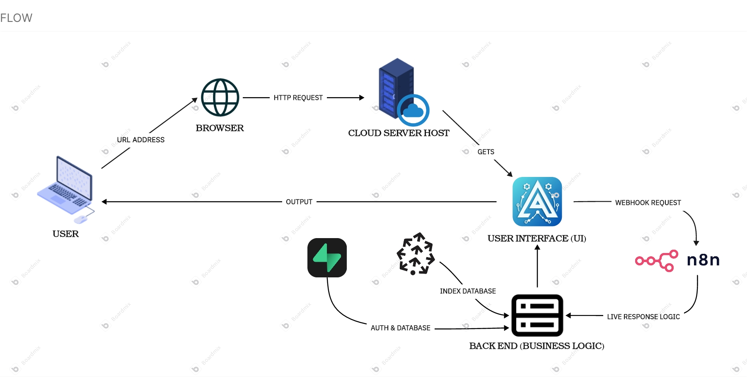

## CLICK ME TO GET STA

## 

## RTED

ACCOUNTS & PLATFORMS

# ACCOUNTS & PLATFORM SET UP CONFIGURATION

In this page we will tackle what are the accounts and platforms needed to build **AILA** from scratch.

**ACCOUNTS & PLATFORM NEEDED TO SET UP:**

*This needs to be in-order.*

*All of these are interconnected*

*BEFORE STARTING YOU MUST CREATE A NEW***GOOGLE ACCOUNT**

**FLOWCHART**

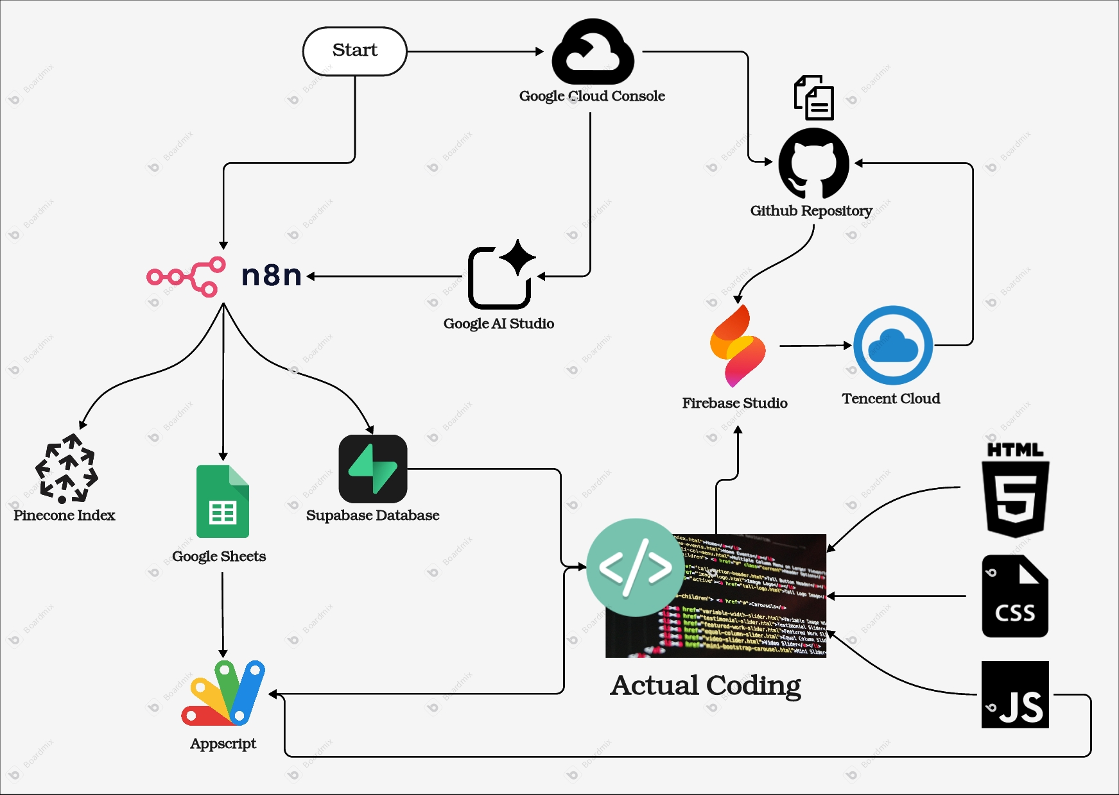

| **Google Cloud** | This will be our platform to configure the API keys for the LLM models and to use for the google auth login. |
| --- | --- |
| **Github** | This will be the platform we’ll use as a version control and file storage. |
| **Tencent Cloud** | This is the cloud platform we’ll use in publishing our code in the internet (web address) |
| **Firebase Studio** | This will be the platform we’ll use to edit and configure the code. |
| **N8N** | This is the platform we will be using to automate the workflow and live AI response. |
| **Supabase** | This platform will act as our database and authentication storage for user login and chat history |
| **Pinecone** | Place to easily store your files for context that are turned into binary format for light conversion. |
| **Google sheets** | This will be the database for the offline response, also storing user login logs |
| **Appscript** | This is connected to the Google sheets |
| **Actual Coding** | This is the last phase to set-up and configure the front end and back end |

1. Google Cloud Console

# Google Cloud Console

**Google Cloud Console** is a web-based interface provided by Google to manage and configure various cloud services offered by Google Cloud Platform (GCP). It's the main tool used for interacting with and managing resources on GCP, which includes services for computing, storage, databases, machine learning, networking, and more.

1. [Go to google cloud console](https://console.cloud.google.com/)
2. Login using your google account (note: you are already logged in by default)
3. Accept all the checkbox

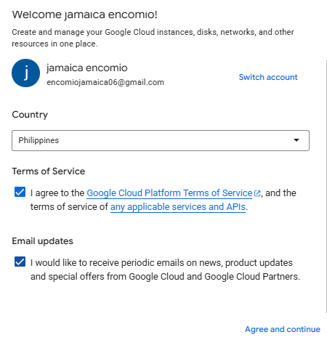

1. Click **Agree and continue**
2. Click **Select a project** (*Found in the upper left corner*)



1. Click **New project** (*Found in the upper right corner of the pop-up*)



1. **Fill up** the following: (*You can insert your own project name*)

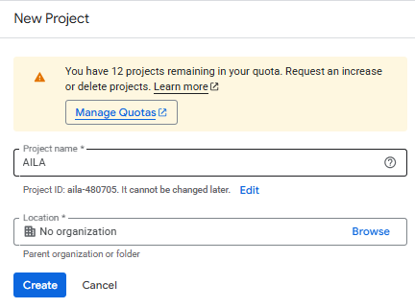

1. Click **Create**
2. Click **Select a project** again



1. Select the project you’ve just **created**

(**now on the fun part, getting your own API key**)

1. [Go to google AI studio](https://aistudio.google.com/)
2. Click the **Get API key** (*found in the lower left corner)*

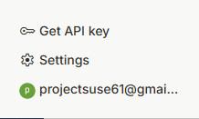

1. Click **Create API key** (found in the upper section right corner)

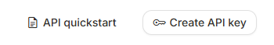

1. Click **Select a Cloud Project**
2. Select **Import Project**

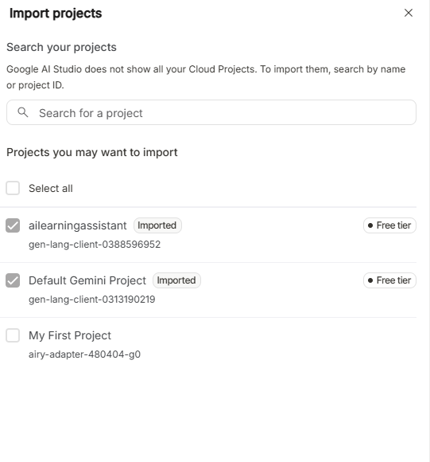

1. Select the project you’ve created awhile before
2. Click **Import**

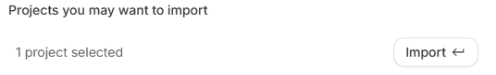

1. After Importing your project
2. **Select** it

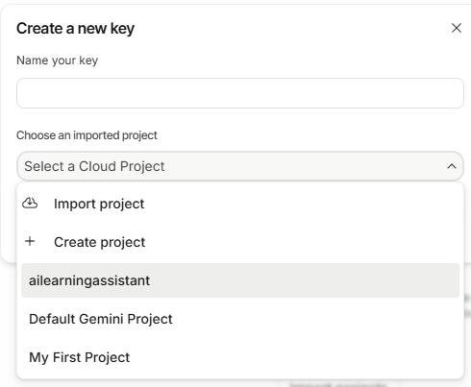

1. Put a name for your **KEY**

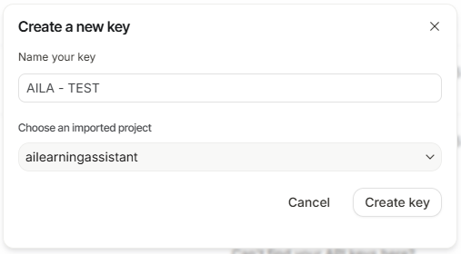

1. Click **Create Key**
2. Congrats! You’ve just created your own **API Key** (this is used for n8n AI model)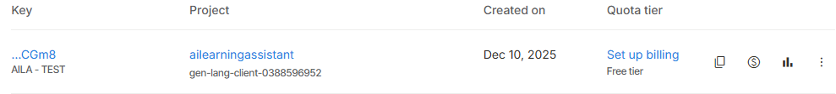

(you can choose to set up your billing account and claim your first free $300)

### CLICK ME TO GO BACK

2. Github

# Github

GitHub is a platform for hosting and collaborating on software projects. It's built around **Git**, a version control system that helps developers track changes to their code over time, manage multiple versions, and collaborate with others.

1. [Go to github and create your first account](https://github.com/signup?ref_cta=Sign+up&ref_loc=header+logged+out&ref_page=%2F&source=header-home)  
   (you can skip this step if you already have an account)
2. Click **Continue with Google**

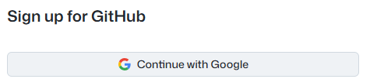

1. Select your **Google Account**

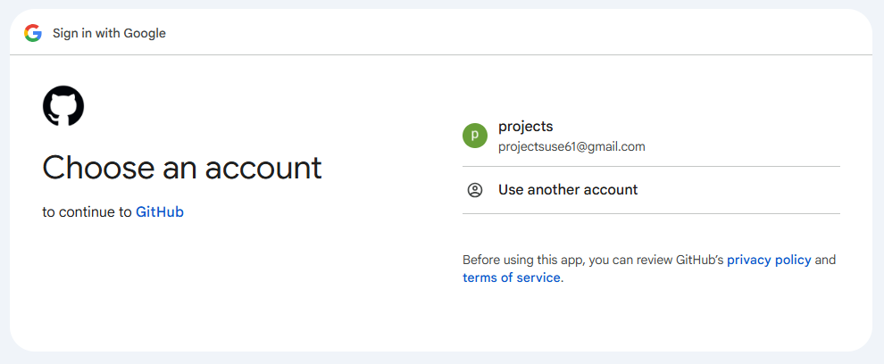**\**

1. Click **Continue**

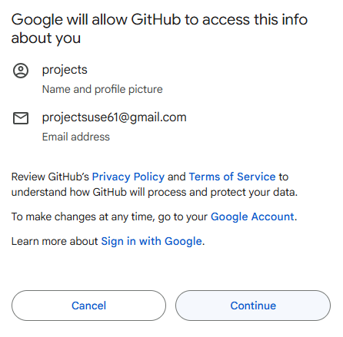

1. Click **Create Account** to continue
2. After **Creating an Account**
3. Navigate to <https://github.com/FrekiJoms/AILA>

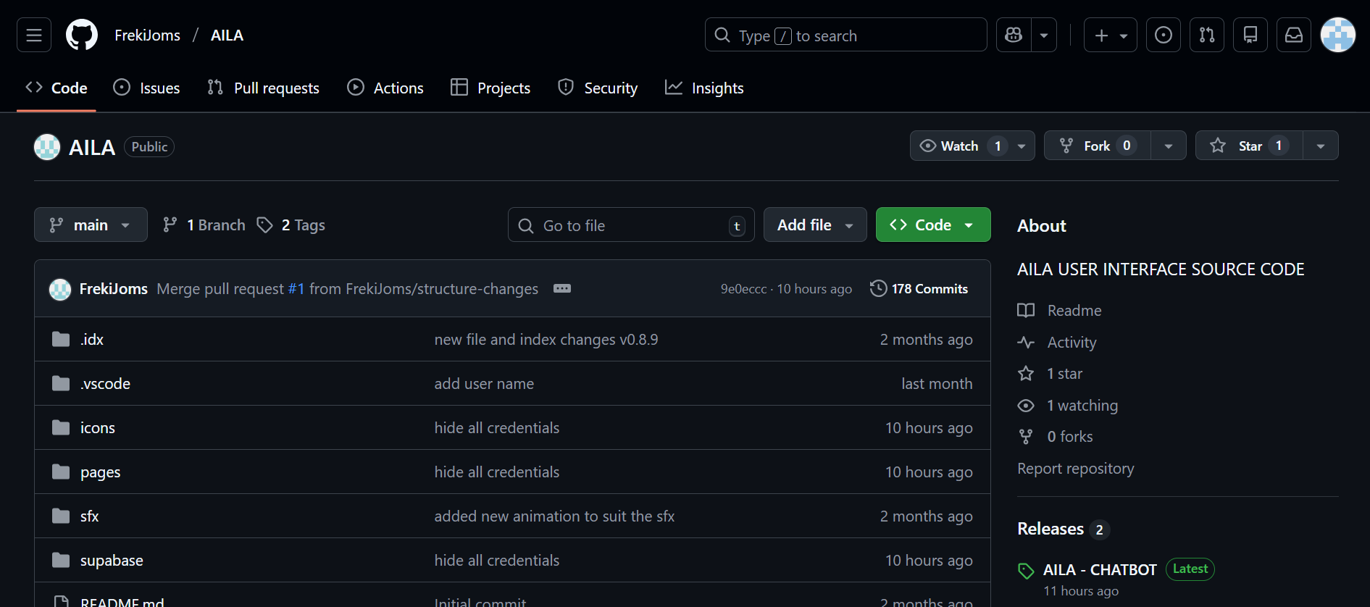

1. Click **Fork** found in the upper left section next to the **Star**

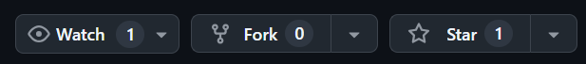

1. Add a name

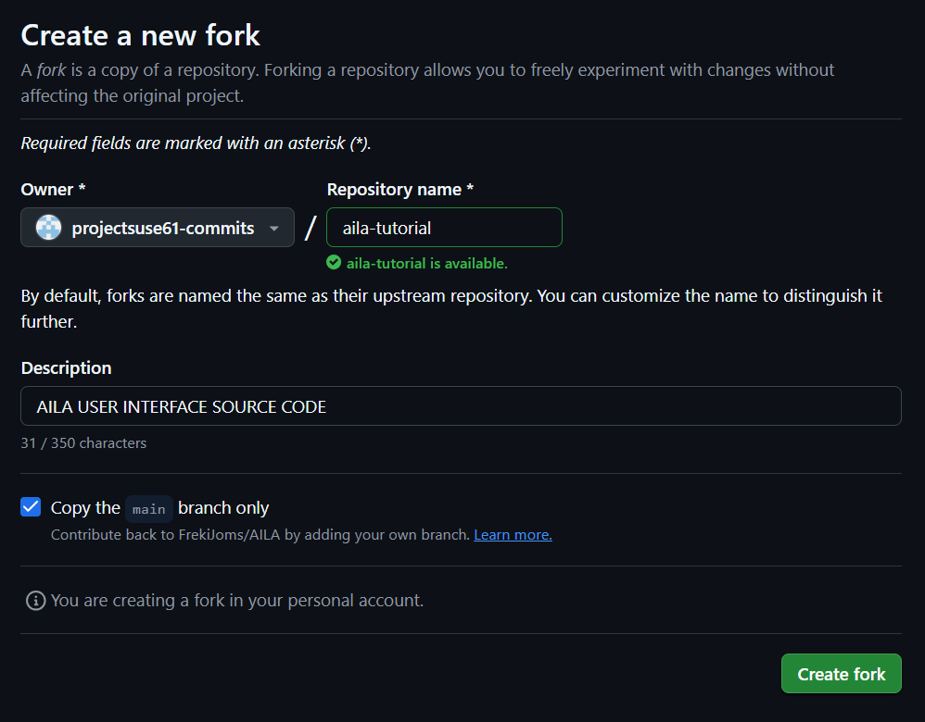

1. Click **Create Fork**
2. Edit the files using FIREBASE STUDIO

CONGRATS! YOU’VE JUST MADE YOUR OWN FIRST REPOSITORY ON GITHUB!  
  
CLICK ME TO GO BACK

3. Tencent Cloud

# Tencent Cloud

Hosting a website on **Tencent Cloud EdgeOne** allows you to take full advantage of **edge computing** and **global CDN** services, resulting in faster load times, improved user experience, better scalability, and enhanced security. By processing data closer to users and distributing content across a global network, **EdgeOne** helps your website perform efficiently even as it grows, ensuring that users across the world have fast and secure access to your site.

1. [Go to Tencent Cloud](https://console.tencentcloud.com/edgeone/zones)
2. Click **Log in with google**
3. After successful log in you will see something like this:

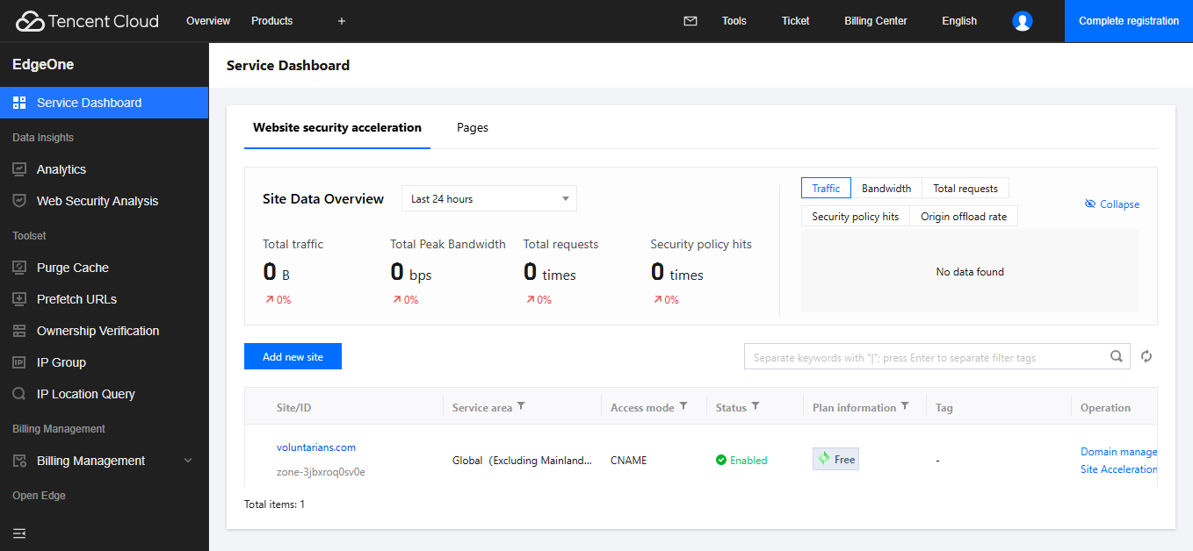

1. Click **Pages**
2. Click **Create project**

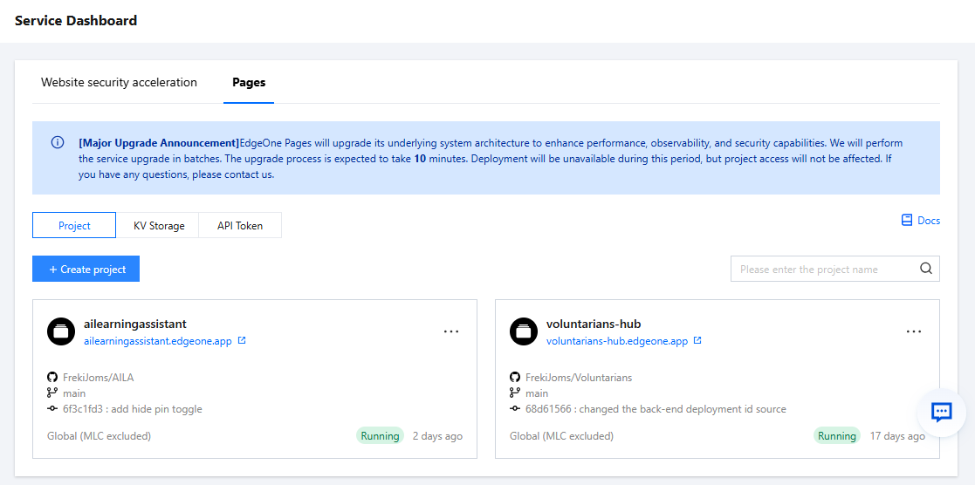

1. Click **Import Git repository**

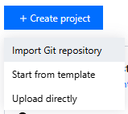

1. Login your **Github account**

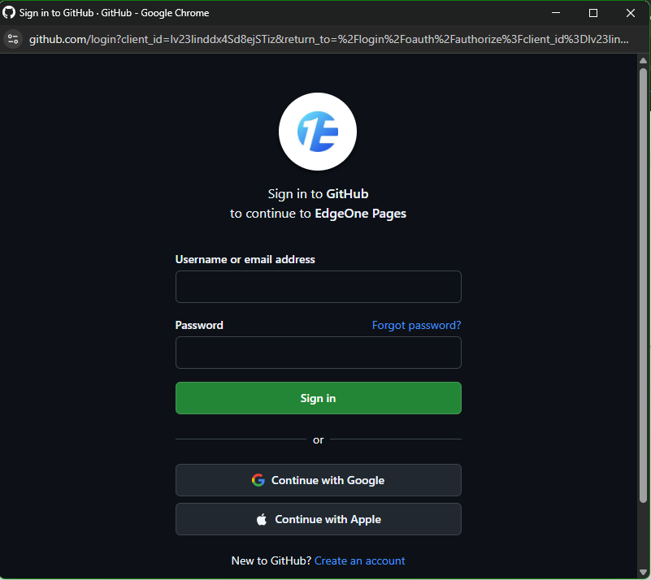

1. Click the Github Repository you’ve created awhile before

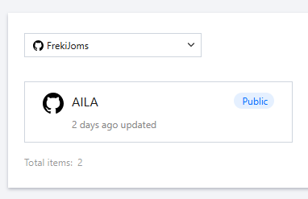

1. Click **Start Deployment**

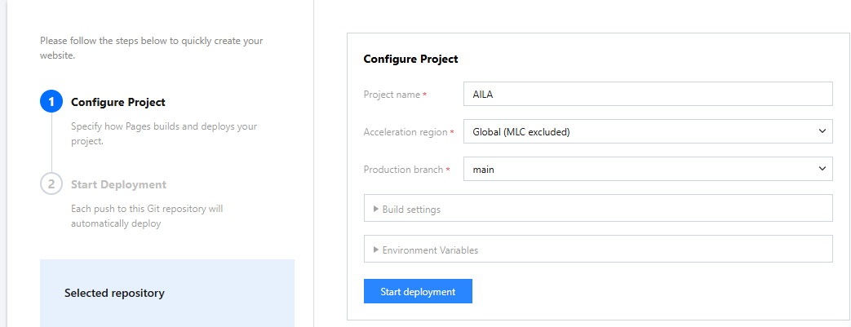

1. After successfully deploying your **Github Repository** every changes done in your code(repository) will automatically deploy making your deployed web-app always up to date

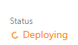

**CONGRATS!! YOU’VE SUCCESSFULLY DEPLOYED YOUR OWN WEB APP**

### Every changes made to your source code will make your website auto redeploy

### CLICK ME TO GO BACK

4. Firebase Studio

# Firebase Studio

**Firebase Studio** is a **new code editor** that **Google Firebase** introduced to help developers build, manage, and deploy Firebase-powered applications more easily. It is designed to be a **simplified environment** that combines development and Firebase integration into one streamlined interface. You can think of it as a specialized, **Firebase-focused** code editor that helps you write and test code **without jumping between different tools**.

What’s good about this platform is that it has a built-in AI(gemini) debugger that is attached directly to your files and can help you debug, add, modify your code.

1. [Go to firebase studio](https://studio.firebase.google.com/)

(*there is no need to login as this is connected through your google cloud and google account)*

1. Click **Import Repo** *(Found in the lower left corner)*
2. Go back to your **Github Repository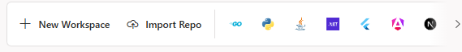**Copy the **URL ABOVE**



1. Go back to your firebase
2. Paste it inside the **REPO URL**
3. Name your workspace

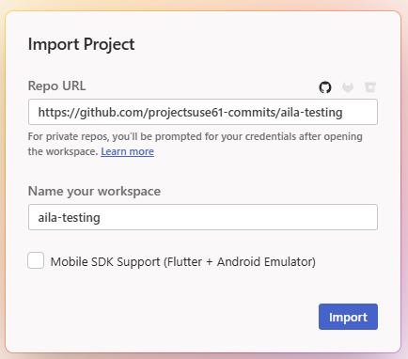

1. Click **IMPORT**
2. Wait for the workspace to load

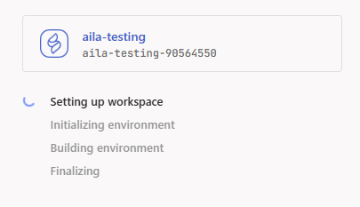

1. Wait for your repository to clone for a verification pop up

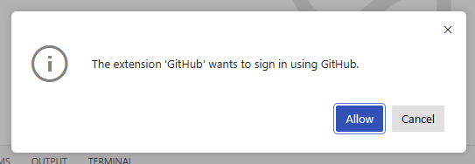

1. Click **ALLOW**
2. After clicking another confirmation will pop up *(for security reasons)*

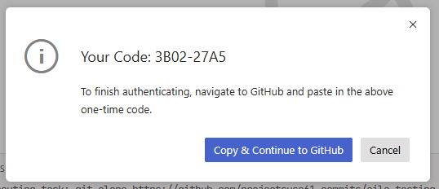

1. Click **Copy & Continue to Github**

Select your account and click **CONTINUE***(to activate)*This will pop up *(since we did not sign in our github in mobile app we’ll try another way)*

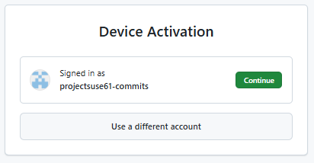

1. Go back to **Firebase studio**
2. Click **Cancel** on the floating card found in the lower right corner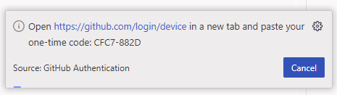
3. After clicking **Cancel** a floating card will pop-up *(for the second way to login)*

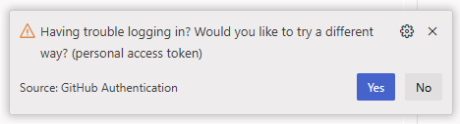

1. Click **Yes**
2. Click **Continue to Github**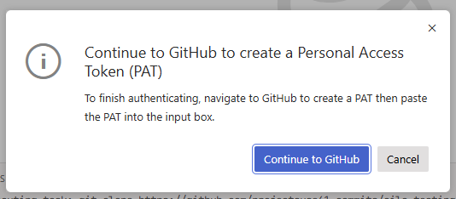
3. This page will pop-up (*scroll down to the very end)*

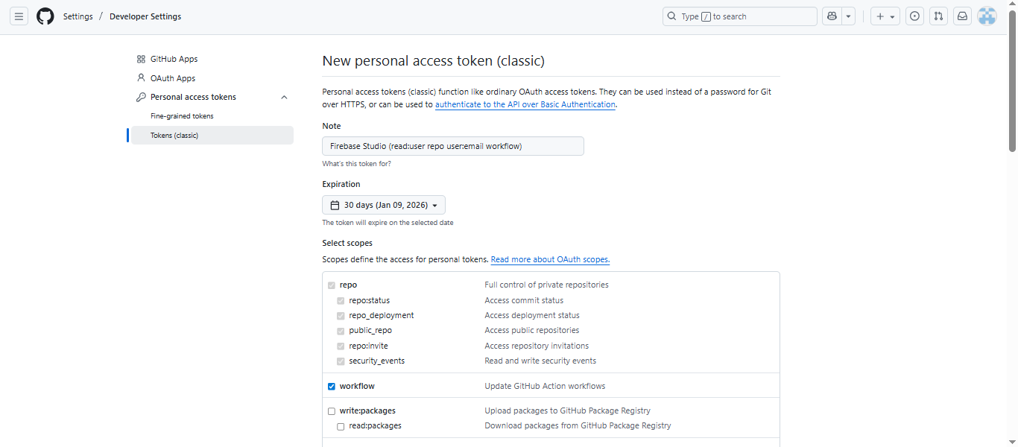

1. In the bottom you will find this button:



1. Click **Generate Token**

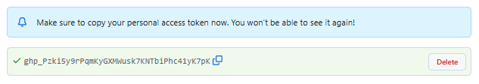

1. **Copy** the Generated token
2. Go back to **Firebase Studio**
3. Paste the token in the textarea found in the upper mid section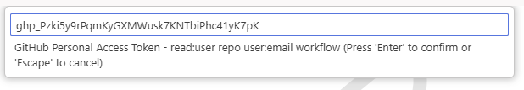
4. Press **Enter** in your keyboard
5. After **Confirming** a card will pop up in the lower right corner: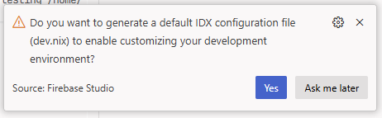
6. Click **Yes**

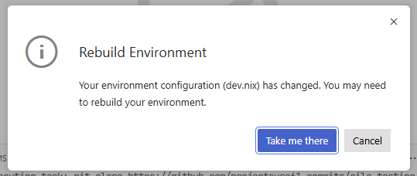

1. Click **Take me there**

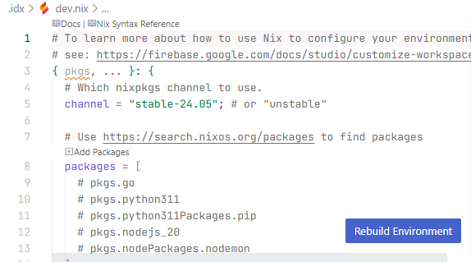

1. Click **Rebuild Environment**

#### Wait for the environment to finish rebuilding

#### **NOTE: EVERY CHANGES IN YOUR FILES ALWAYS DO:**

* + - INSERT COMMIT NAME
    - CLICK COMMIT
    - CLICK SYNC CHANGES

(*THIS IS TO MAKE YOUR GITHUB REPOSITORY(FILES) ALWAYS UPDATED)*

* 1. SETUP THE NEEDED EXTENSIONS

1. Navigate to **Extensions**

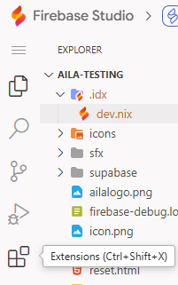

* 1. Search **rickwickdey** or **Live Server** in the search bar

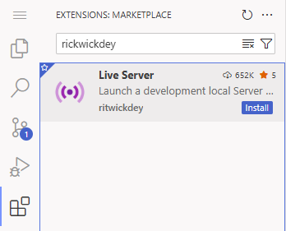

* + - Click **Install**

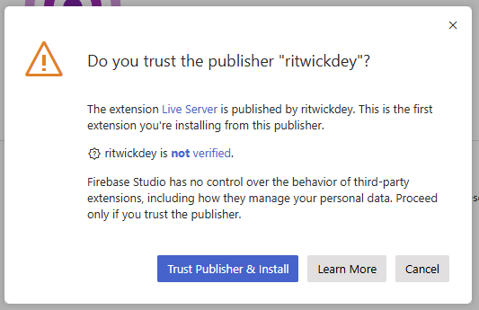

* + - Click **Trust Publisher & Install**
    - The extension should load successfully after doing the steps correctly.

**CONGRATS!! YOU’VE JUST SUCCESSFULLY SETUP YOUR FIRST FIREBASE STUDIO WORKSPACE…**

### CLICK ME TO GO BACK

5. N8N

# N8N

**n8n** is an open-source automation platform that allows you to automate workflows, integrate different applications, and perform tasks across various services, all without needing to write complex code. It’s like a **visual programming tool** where you can set up workflows (or "flows") that link multiple applications together, automating actions and making processes more efficient.

1. [Go to n8n official website](https://n8n.io/)

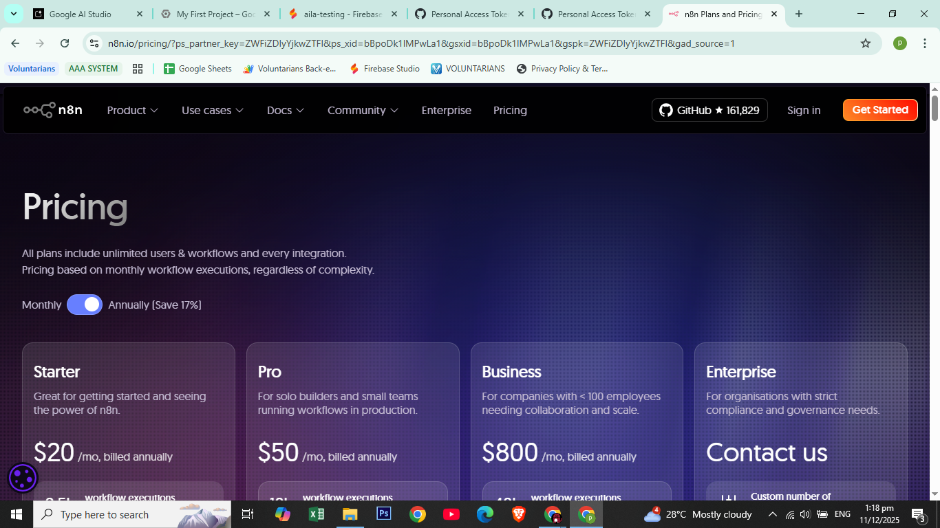

1. Click **Get Started** *(Found in the upper right corner)*

**

1. Fill up the registration form

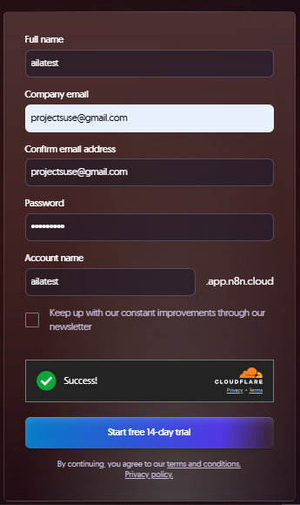

1. After filling up, click **Start free 14-day trial.**
2. After clicking the button you will be directed to this page.

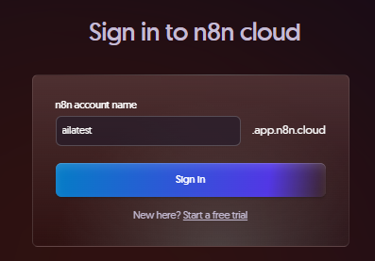

1. Insert the account name that you registered
2. Click **Sign In**
3. After clicking the **Sign In** button you will be needed to login again on the account that you’ve recently registered

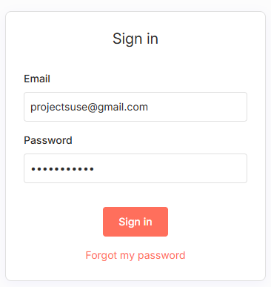

1. After inputting your **Email** and **Password**
2. Click **Sign In** (*AGAIN)*
3. After successfully signing in you will be directed to this page below:

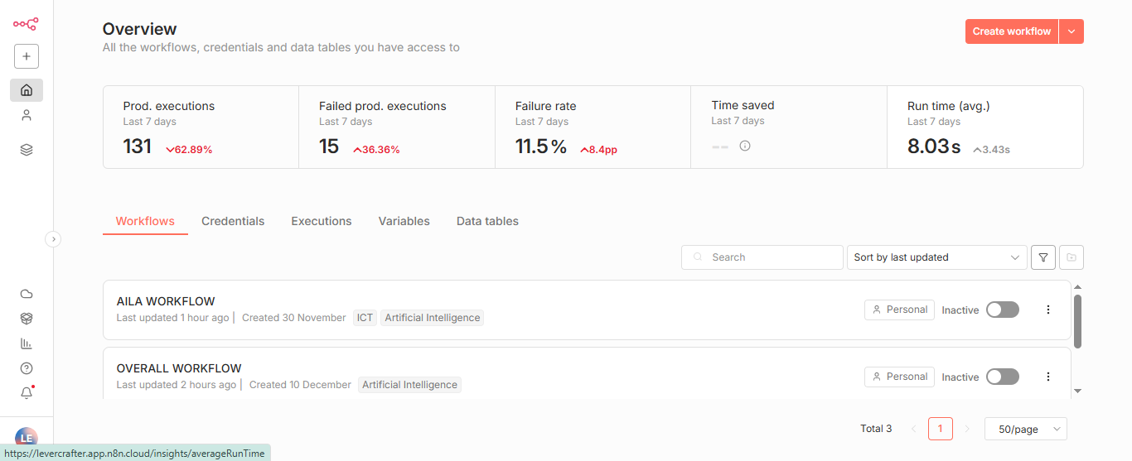

**NOTE:** *This page is shown if you already made a workflow, so you can skip some steps below*

*If it’s your first time creating an N8N account you will be directed automatically to the workflow creator.*

1. Click **Create workflow** *(found in the upper left corner)*

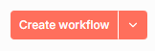

1. After clicking the button you will see something like this: *(when first time creating an account you will see this page first)*

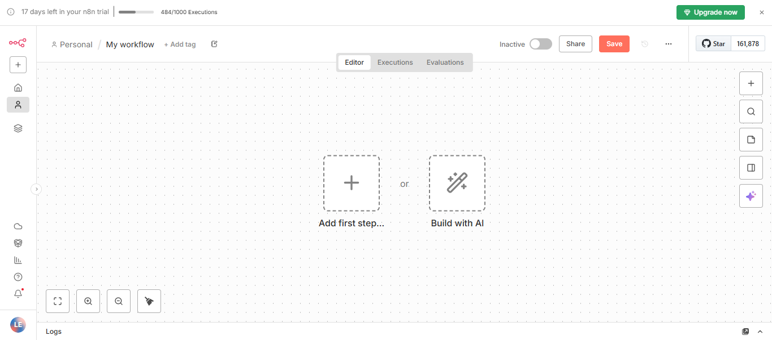

1. Click **Add First Step**
2. A sidebar will slide from the right
3. Search **Webhook**

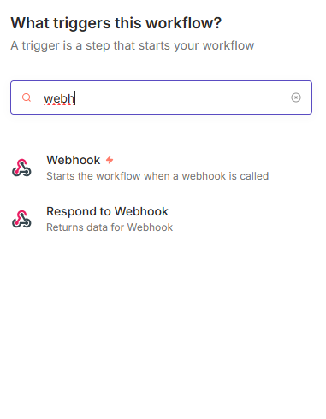

1. Click **Webhook** *(The first result)*
2. This page will pop up

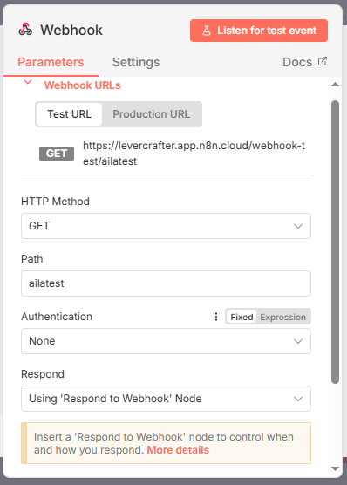

1. Make sure to fill up the following based on the picture above
   1. **HTTP Method -** Set it to **GET**
   2. **Path** - Insert your workflow name here
   3. **Respond -** Change it into “**using Respond to Webhook Node”**
   4. Leave the other settings
2. After configuring the node click **Back to canvas** or click **ESC button** in your keyboard

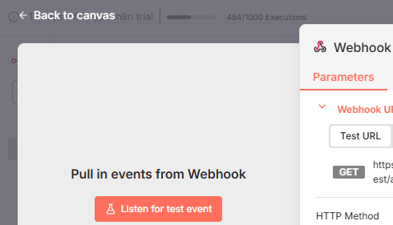

1. You successfully created your first node

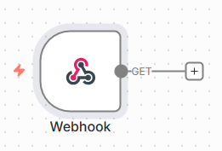

1. Click the [+] button you see in the right end of the webhook node
2. The side bar will appear again
3. Searchfor **merge**

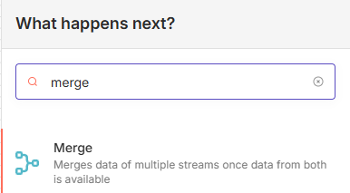

1. Click **Merge**
2. Setup the following:
   1. **Mode -** Set it to **Combine**
   2. **Combine by -** Set it to **All Possible Combinations**

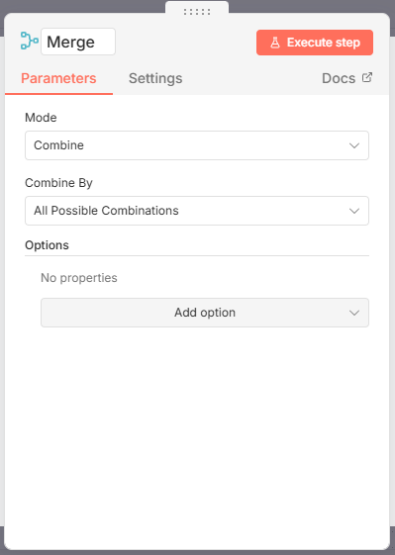

1. Go back to your **Canvas again**
2. Adjust the position and distance

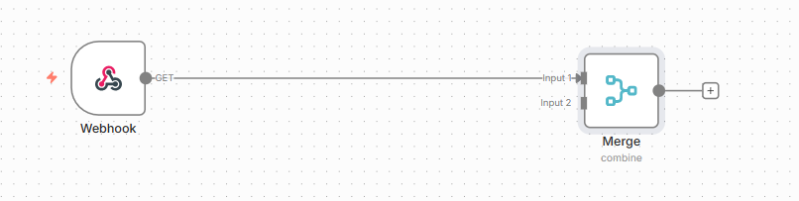

1. Click the [+] button in the right to open the nodes panel

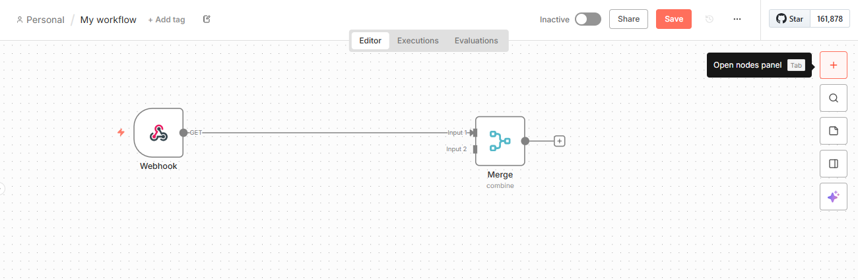

1. Search for **Supabase**

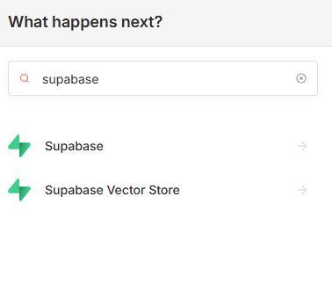

1. Click the first result (**Supabase**)
2. Click **Get a row**



(*Click me to set-up* ***SUPABASE*** *credentials)*

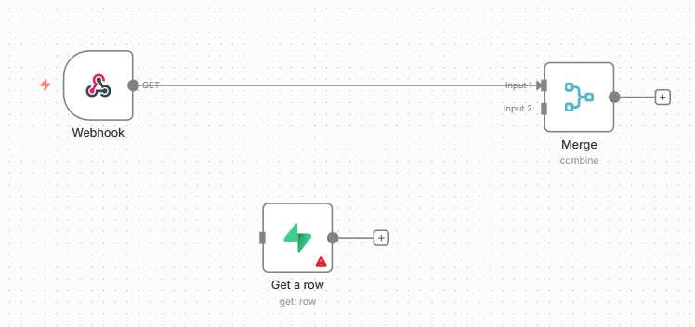

1. Connect it to your webhook node.

##### **HOW TO CONNECT NODES TOGETHER**:

* + 1. Hover your cursor above the dot ⚫ found in the webhook

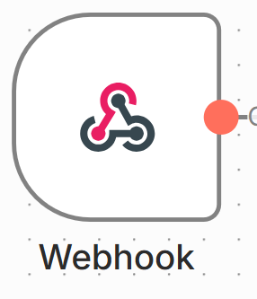

* + 1. When hovering your cursor above the ⚫ it will turn 🟠 and has (+)
    2. Hold your left click in your mouse to drag the connection string:

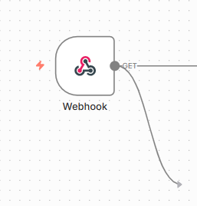

* + 1. Drop it in the front of the **Supabase** node to connect it

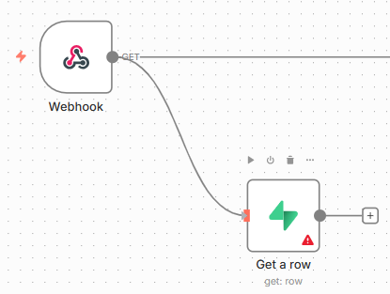

* + 1. Congrats! You’ve now learned how to connect nodes together!!

1. Click the [+] in your **Supabase** node
2. Add an **Aggregate** node to combine list of data into one
3. Search for **Aggregate**

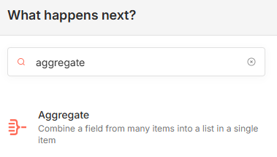

1. Click it to add
2. Fill up the following
   1. **Aggregate -** Set it to **All item Data (into a single list)**
   2. **Put Output in Field -** Set ut to **Data**
   3. **Include -** Set it to **All Fields**

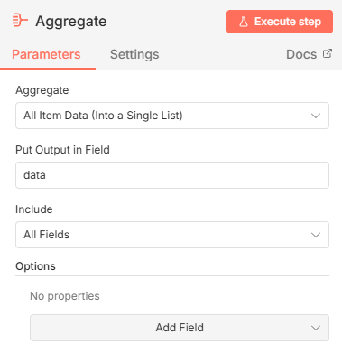

1. Go back to your **Canvas**

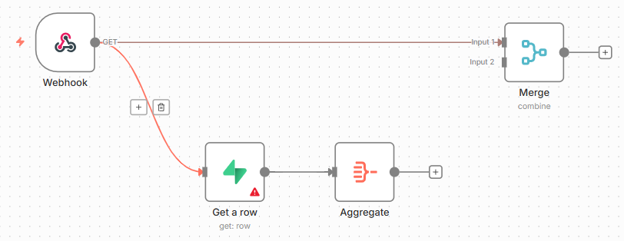

1. Connect your **Aggregate node** to the **(INPUT 2)** of your **Merge node**

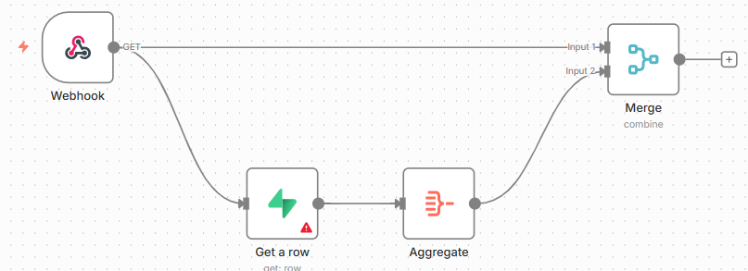

1. Click the [ + ] in your **Merge node**
2. Search for **AI Agent node**

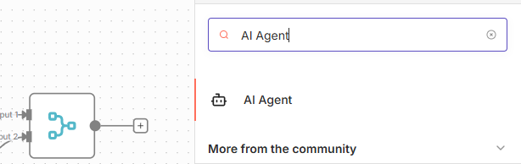

1. Click the **AI Agent node**
2. Setup the following
   1. **Source for Prompt -** Set it as **Define below**
   2. **Prompt (User Message) -** Copy this including the curly bracket: {{ $json.body.message }}

Put it inside the textbox

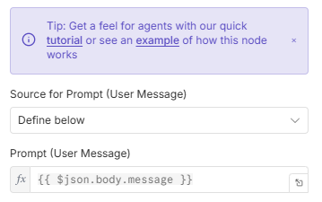

* 1. Scroll down til you find the **Add Option** button
  2. Click The button

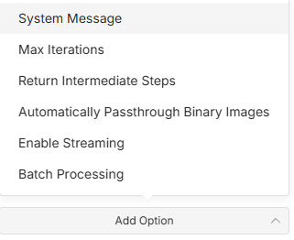

* 1. Select and click **System Message**

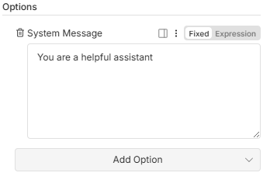

* 1. Learn here to know how to correctly modify your **system message**

1. After **Setting up** your **AI Agent node**
2. Add a **chat model**
   1. When adding an AI chat model you will see a wide range of choices
   2. But I recommend [**Gemini**](https://aistudio.google.com/) as this is the model we set up a while before
   3. [**Open router**](https://openrouter.ai/) is also a recommend as it offers a wide range of AI models from free to paid

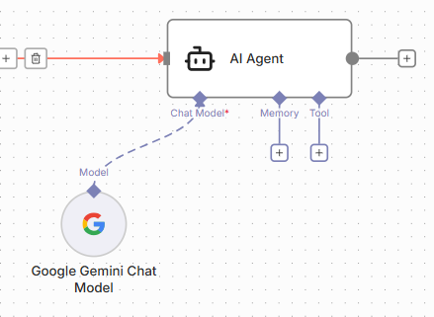

* + - * Set up google gemini credentials:
      * Create a new credentials:

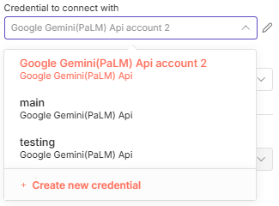

* + - * Go to [AI STUDIO](https://aistudio.google.com/)
      * Click **Get API KEY**
      * Copy or Create a new key

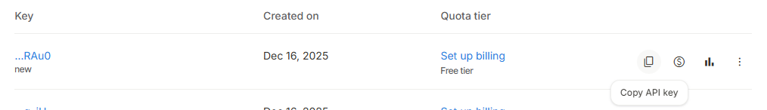

* Paste your AI Google studio API KEY here

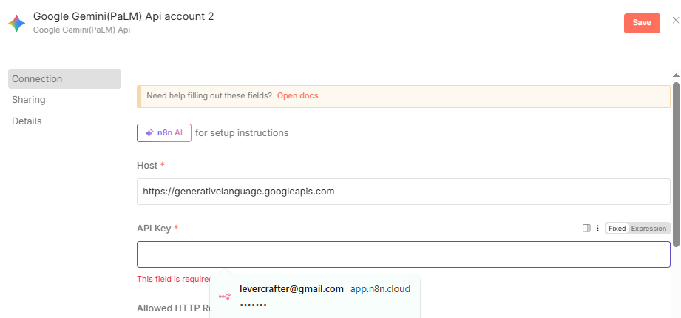

* + - * Click **Save**
      * If done correctly it will show something like this:

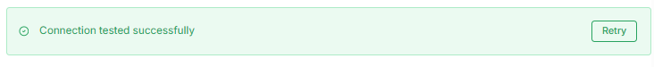

1. Add a **memory**
2. Select **Simple memory**

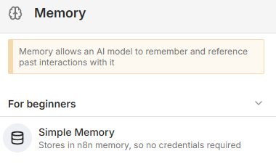

1. Configure the **Memory**
   1. **Session ID -** Set it to **Define below**
   2. **Key -** Set it as {{ $json.body.sessionId }}
   3. **Context Window Length -** Set it to **20** or **More**

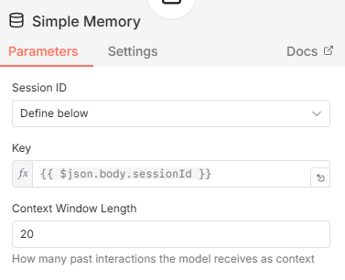

1. Add **Tools:**
   1. **Important TOOLS:**

###### **Supabase -** For memory saving

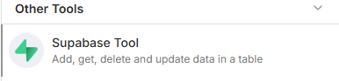

Click me to modify this **SUPABASE** node.

* + 1. **(OPTIONAL) Google sheets** - Simple database for getting information for your AI

CLICK ME TO SETUP THE SHEETS

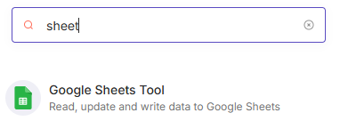

You can just create a new sheet in your existing main Google Sheet file and name it whatever you want and connect it inside your node.

**In my case I will connect my offline response sheets**

* + - * Set up the node
      * Select the document and sheet you want to connect

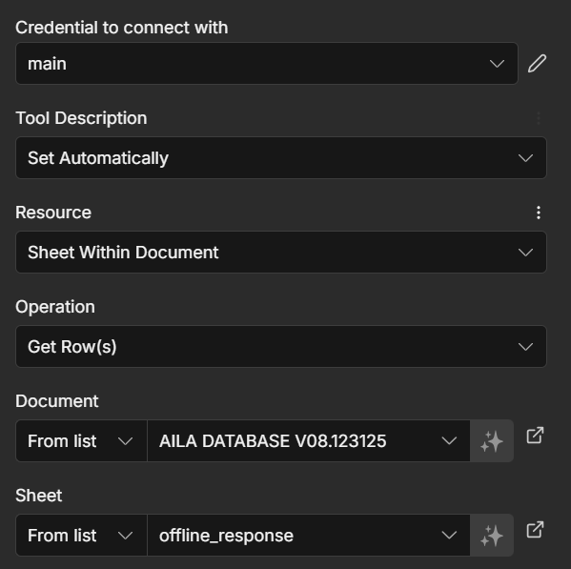

* + 1. **PINECONE VECTOR STORE -** An advance technique that enables large language models (LLMs) to retrieve and incorporate new information (you can insert your files here as database)

##### CLICK ME TO SETUP RAG PINECONE WORKFLOW

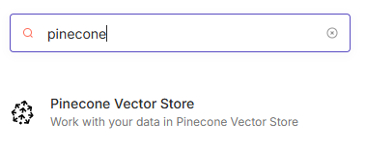

###### After setting up your RAG workflow and pinecone index do the following:

* + - * Go back to your AI workflow
      * Double click the **pinecone vector store tool**

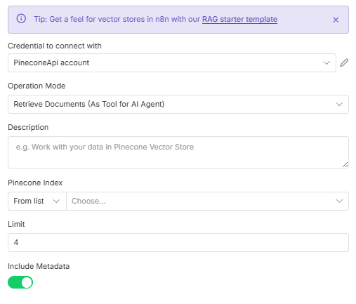

* + - * Select a Credentials
        + Operation mode > **Retrieve Documents**
        + Description > Put a description here like a system message
        + Select your created pinecone index

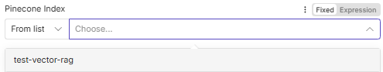

* + - * + Set the limit to 10-20
        + Turn on **Include Metadata**
        + Add an **Option** Select **Namespace**
        + Type in your namespace name exactly

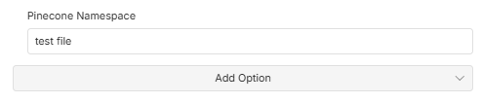

* + 1. Close the node
    2. Add an **Embedding Model**
    3. Select **Google Gemini**

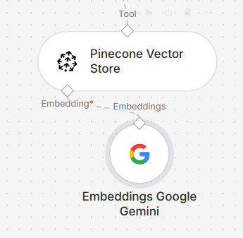

* 1. **Other Tools -** You can add multiple tools as you wish depending on your specifications, But the three **tools** mentioned earlier must be **CONSTANT**

Your workflow will now look like this:

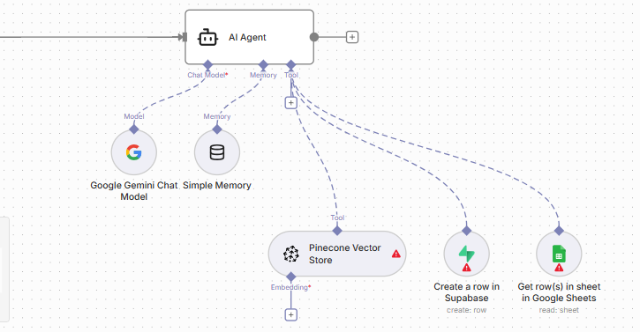

1. At the end your AI Agent
2. Click the [+]

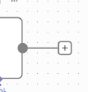

1. Search for **Respond to webhook**

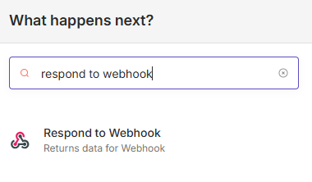

1. Click the **Respond to Webhook**

Modify the node as follows:

* + 1. **Respond With -** Set it to **JSON**
    2. **Response Body -** Copy the following and paste it inside the **Response Body**

| **{  "reply": {{ JSON.stringify($json.output) }} }** |
| --- |
|  |

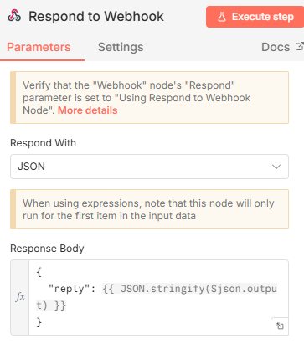

1. Add **google sheets node** at the very end of the workflow next to your response to webhook node for message history saving.

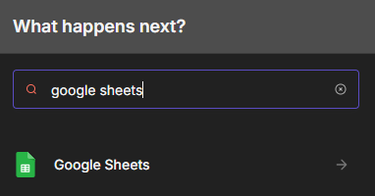

1. Click **Append row in sheet**
2. Click me to setup the sheet

###### Configure the **Google sheets node** with the following:

* + 1. Add your credentials:

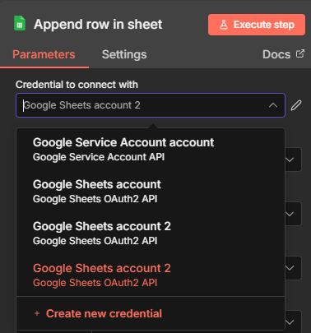

* + 1. Click **Create new credentials**
    2. Click **Sign in with Google**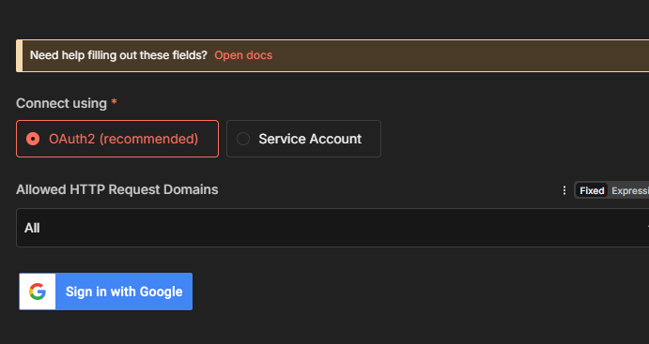
    3. After successfully logging in click **Save**
    4. In the **resource setting** set it as **Sheet within the document**
    5. In the **Operation** set it as **Append Row**

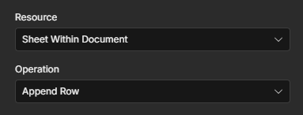

* + 1. In the document **select** the file you’ve just created earlier

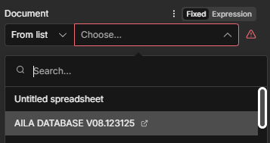

* + 1. In the **Sheet** Select the sheet you’ve just created named “message_history”

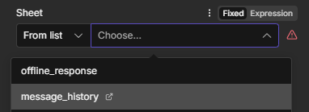

* + 1. Set the following:

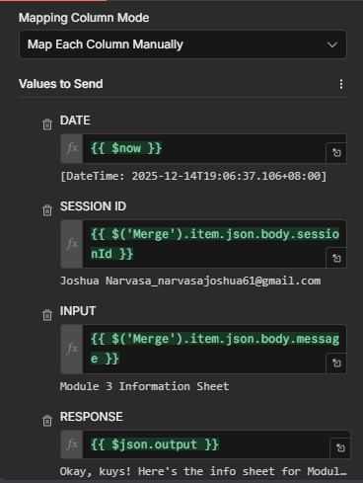

* + - * **Date**: {{ $now.format('D - hh:mm a') }}
      * **SESSION ID:** {{ $('Merge').item.json.body.sessionId }}
      * **INPUT:** {{ $('Merge').item.json.body.message }}
      * **RESPONSE:** {{ $json.output }}

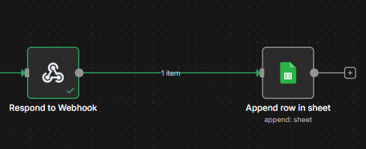

**CONGRATS YOU’VE JUST SUCCESSFULLY FULLY SETTED UP YOUR OWN N8N AI CHATBOT WORKFLOW**

### **CLICK ME TO PROCEED TO ACTUAL CODING**

### CLICK ME TO GO BACK

RAG WORKFLOW

# RETRIEVAL AUGMENTED RETRIEVAL (RAG)

This workflow converts files into binary data then later saved into pinecone vector storage

You can also download the full workflow [**HERE**](https://drive.google.com/file/d/1tjvIg8Sia16Cy0wK-neffpXMgAQeYpNk/view?usp=sharing)

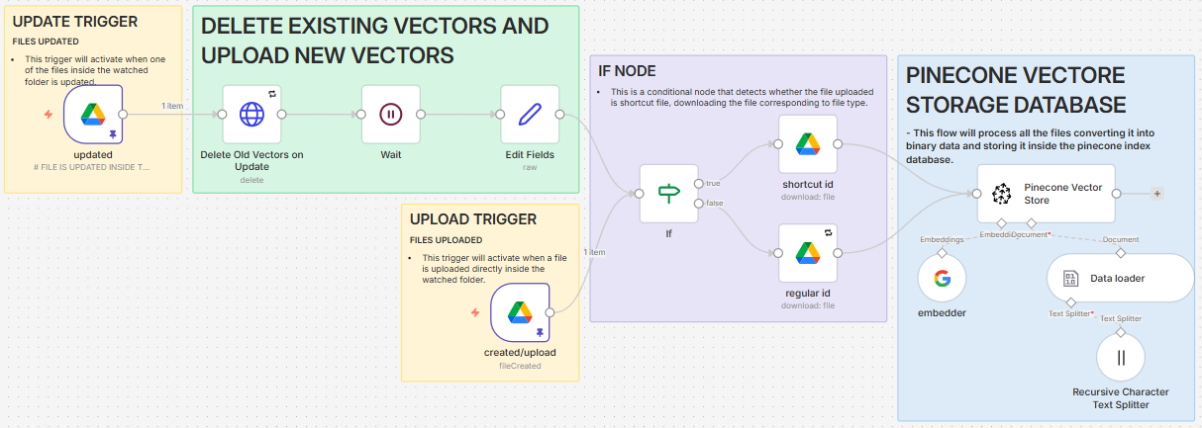

1. Go back to N8N
2. Click **Create workflow**

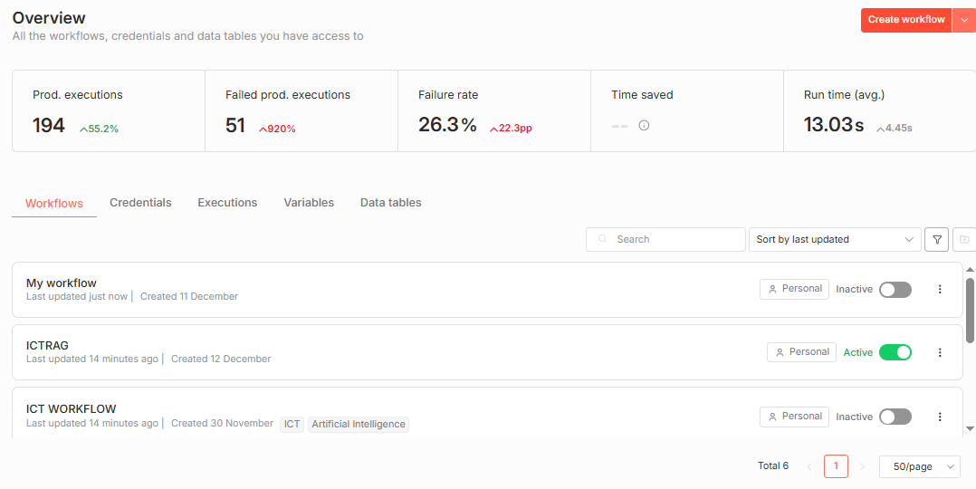

1. Click **Add first step** to add a trigger
2. Search **Google Drive** as trigger

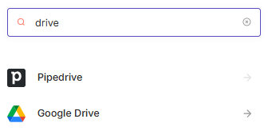

1. Click **Changes involving a Specific Folder**
2. We will be setting up this node:

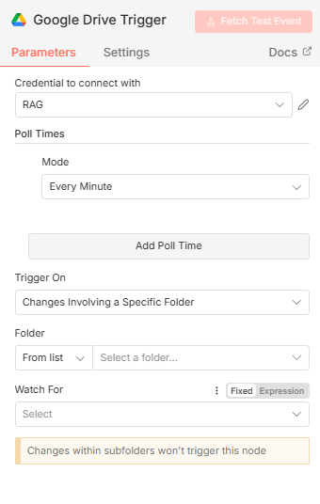

1. Create a new credentials:

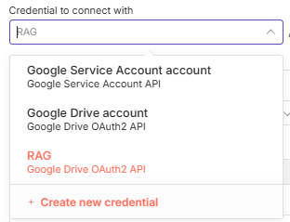

1. To setup this credentials page:

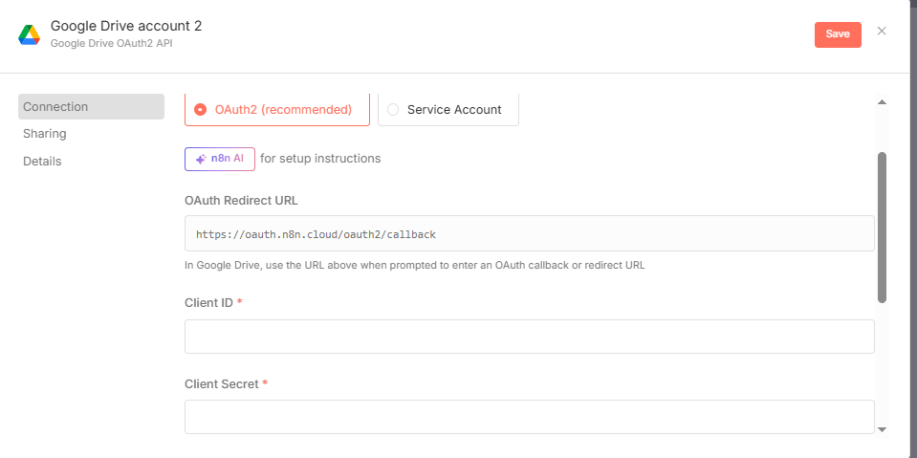

1. Follow the steps carefully:
   1. Go back to your [Google Cloud console](https://console.cloud.google.com/)
   2. Select your project

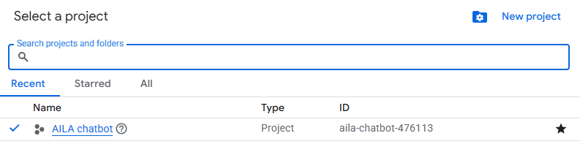

* 1. Open the navigation menu
  2. Select **APISs & Services**
  3. Click **Library**

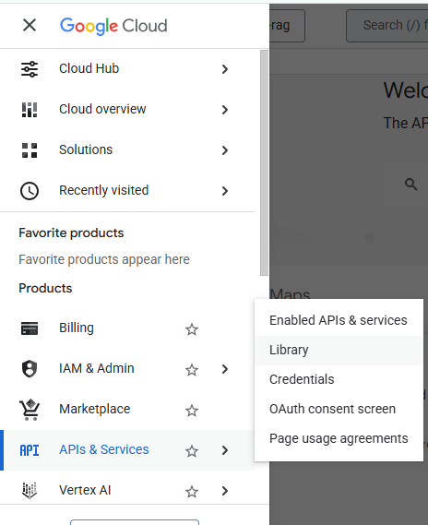

* 1. Search for **Google Drive API**

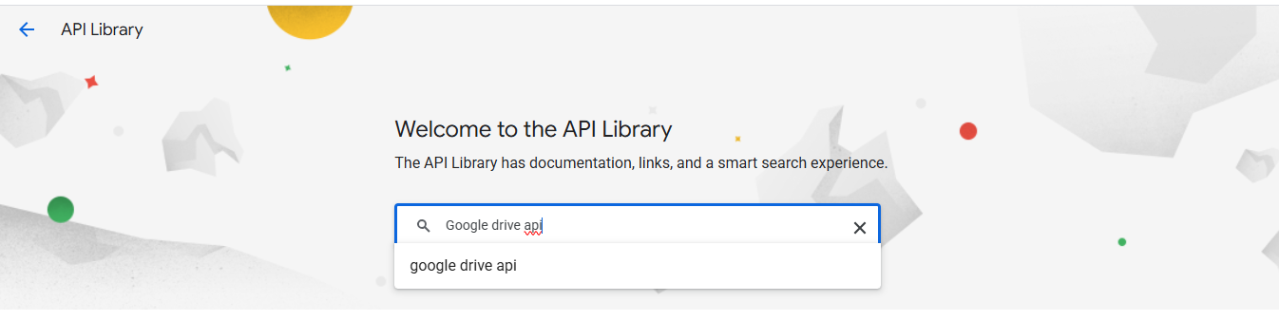

* 1. Click the first result
  2. Click enable

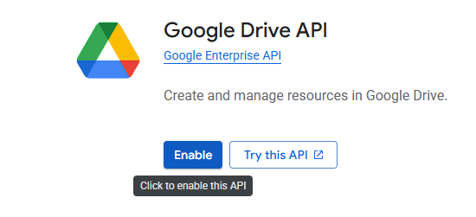

* 1. After enabling the Google Drive API
  2. Click Credentials

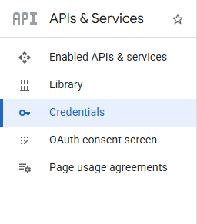

* 1. Click **Create Credentials** at the top of the page

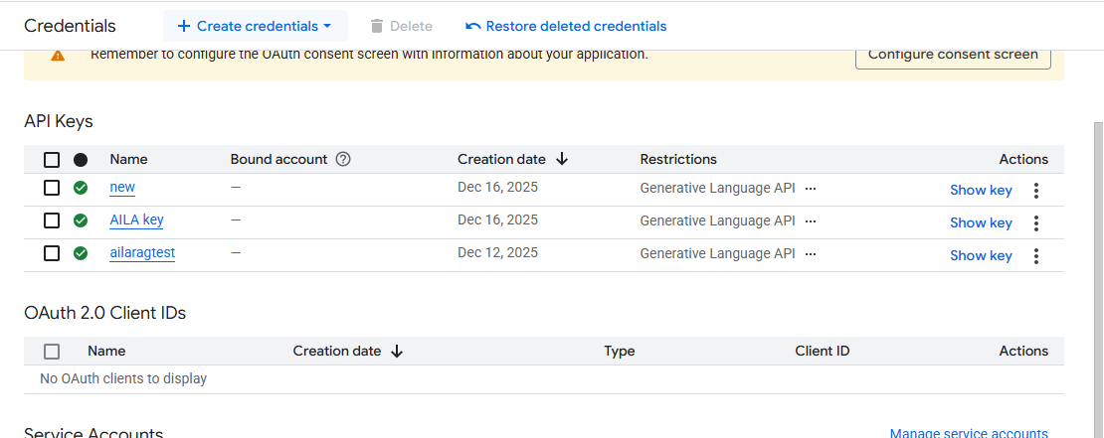

* 1. Select OAuth client ID

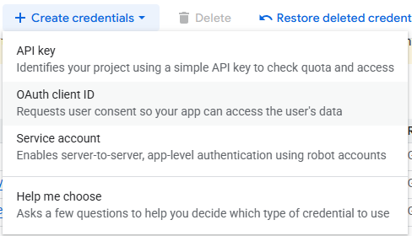

* 1. But before you can set up you must create a consent screen first

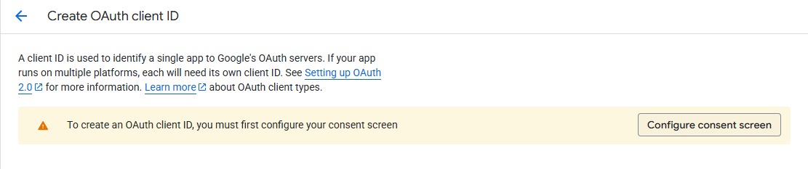

* 1. Click **Configure consent screen**

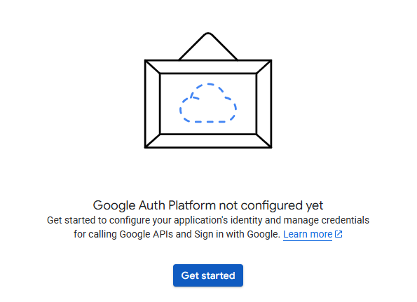

* 1. Click **Get started**
  2. Setup the following:

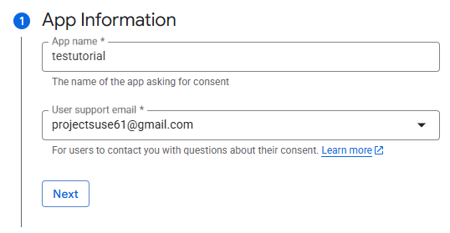

* 1. Click **Next**
  2. Select **External**

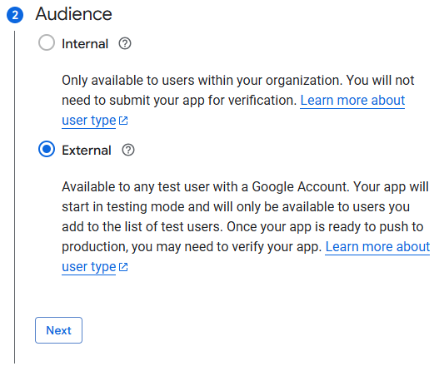

* 1. Input your **Email**
  2. Click **Next**

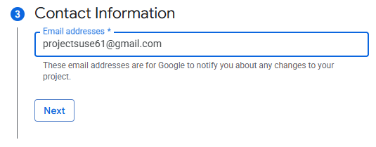

* 1. Agree to the terms of service

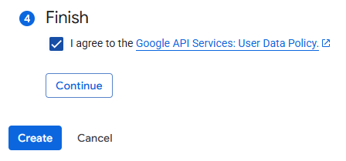

* 1. Click **Continue**
  2. Click **Create**

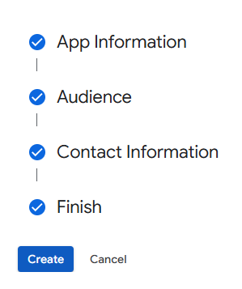



* 1. In the **Metrics**
  2. Click **Create OAuth client**

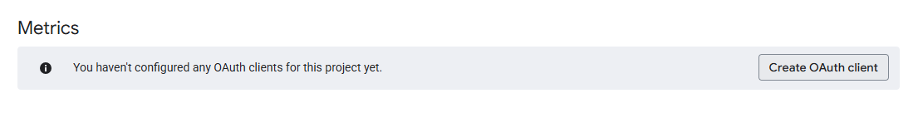

* 1. Click **Application type**
  2. Select **Web Application**

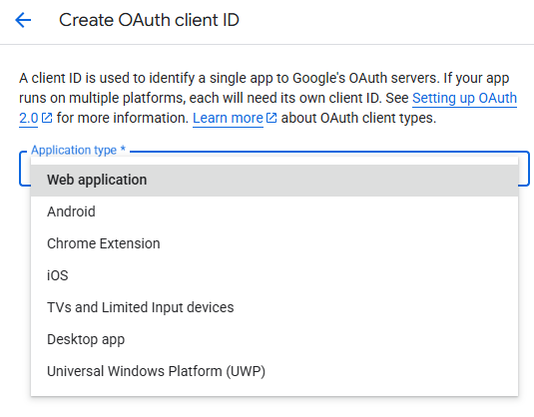

* 1. Input your name

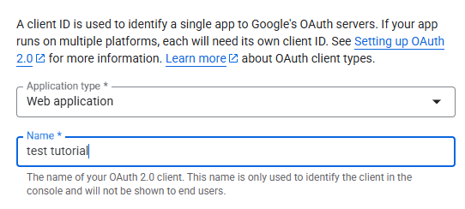

* 1. Scroll down and find **Authorized redirect URIs**
  2. Go back to your N8N credentials page

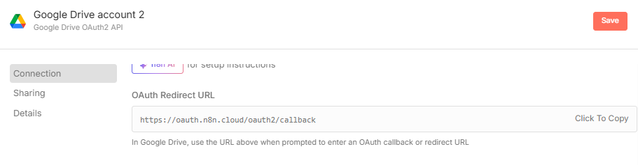

* 1. Copy the **OAuth Redirect URL**
  2. Go back to Cloud Console

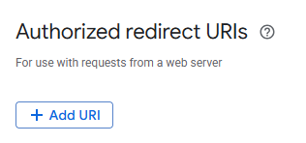\

* 1. Click **Add URI**
  2. Paste the URL that you copied

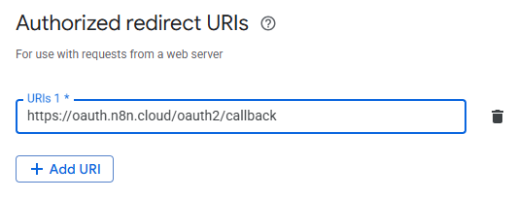

* 1. Click **Create**

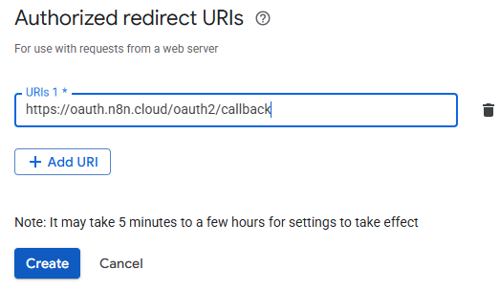

* 1. After clicking the Create Button
  2. This mini-page will pop-up

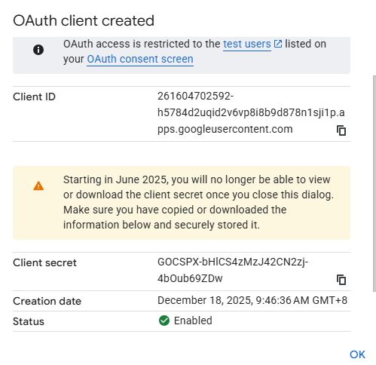

* 1. Copy the **Client ID** by clicking the copy icon

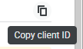

* 1. Go back to N8N credentials page
  2. Paste the **Client ID** that you’ve copied inside the Credentials page **Client ID**

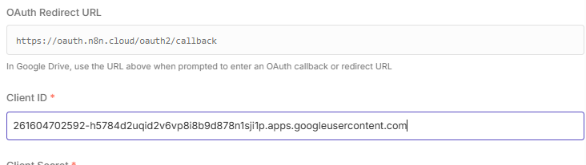

* 1. Go back to Cloud console and copy the **Client Secret**

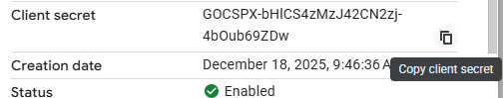

* 1. After copying the **Client Secret**
  2. Paste it inside the credentials page **Client secret**

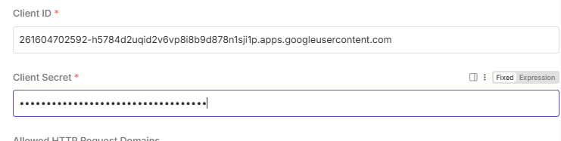

* 1. Open the **Navigation Menu**
  2. Select **APIs & Services again**
  3. Select **OAuth Consent Screen**

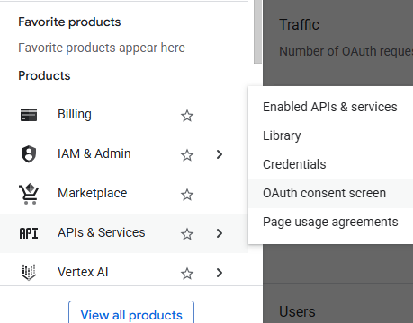

* 1. Click **Audience**

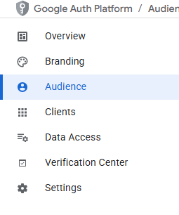

* 1. Click **Publish App**

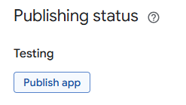

* 1. Click **Confirm**

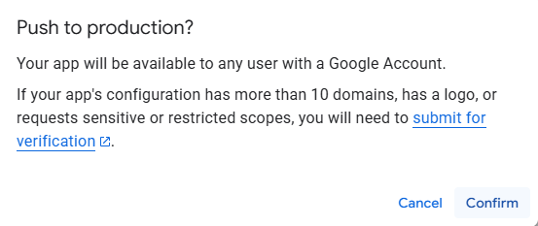

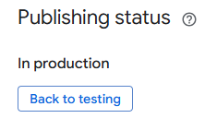

* 1. Go back your n8n credentials page
  2. Scroll **Down**

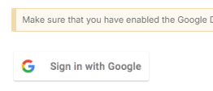

* 1. Click **Sign in with Google**
  2. Login using your Google account

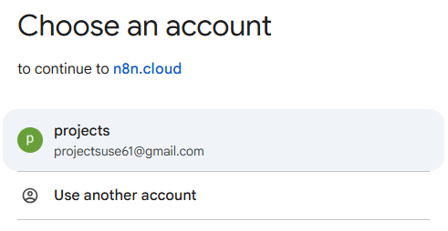

* 1. Click **Advanced**

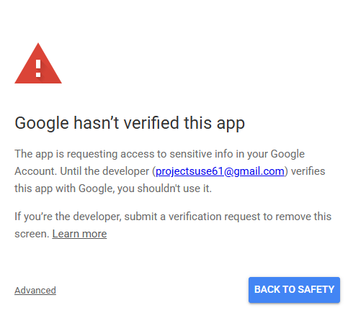

* 1. Click **Go to n8n.cloud (unsafe)**

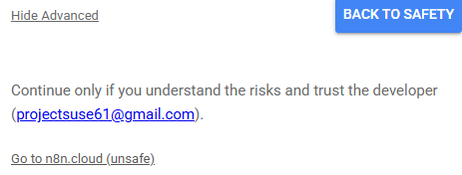

*(since your application is not yet verified by google this safety protocol will show, but it is okay to continue since this is your own application)*

* 1. Click **Select All**

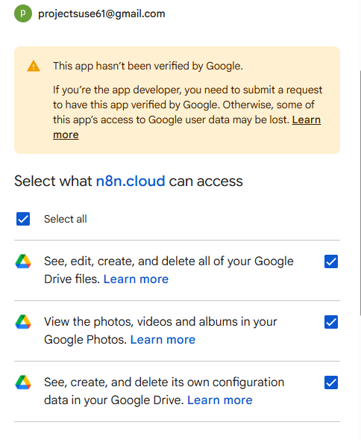

* 1. Scroll **Down**

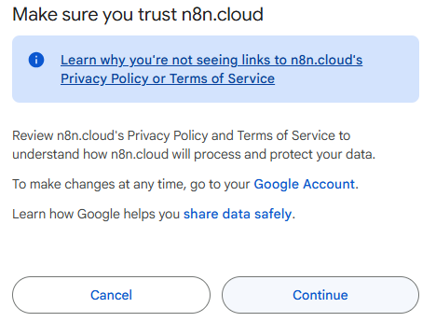

* 1. Click **Continue**

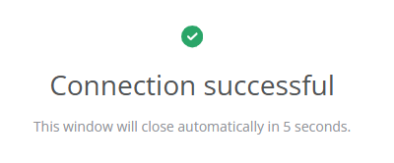

* 1. If done correctly this confirmation will appear

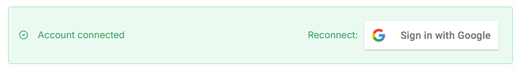

* 1. Click **Save**



* 1. Close the credentials page
  2. Go to your [Google Drive](https://drive.google.com/drive/u/0/my-drive?pli=1)
  3. Create a new folder *(this folder will be your storage for all the files you want to use as context for your AI AGENT pinecone vector store)*

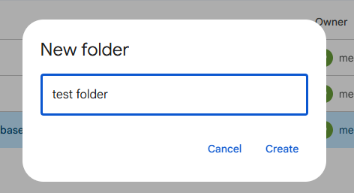

* 1. After creating your folder



* 1. Go back to n8n
  2. Close and re-open your **Google drive trigger** to refresh it
  3. Set the poll time as **Every minute**

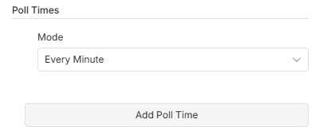

* 1. In the **Folder**
  2. Select the Folder that you created in your **Google Drive**

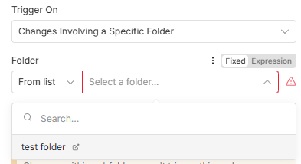

* 1. Set the **Watch for** as **File Created**

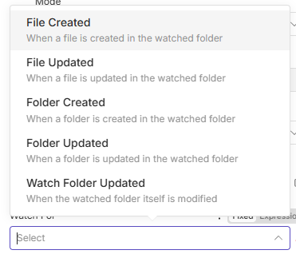

* 1. Add a new option
  2. Select **All**

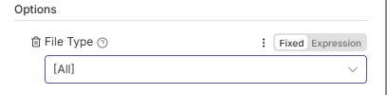

1. Add another google drive node and select **Download**

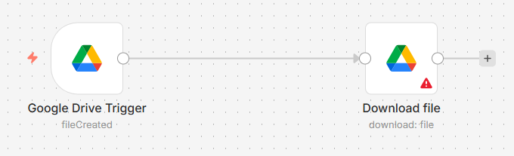

* 1. Configure the node as following:
     + Select your credentials
     + Set the **Resource** as **File**
     + Set the **Operation** as **Download**
     + Set the **File** as **By ID** {{ $json.id }}

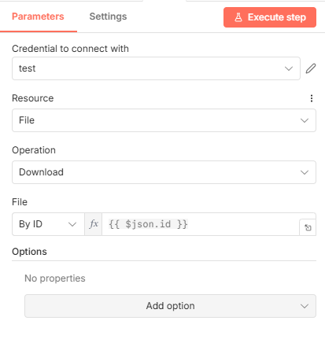

* 1. Add these **options**

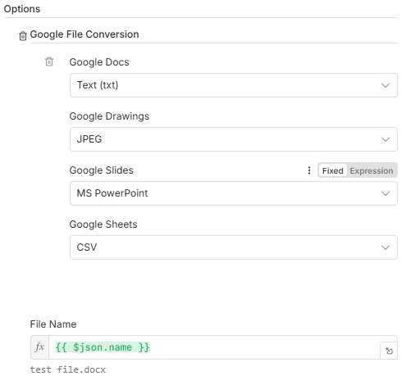

* 1. Test your workflow if it’s receiving data correctly by doing the following:
     + Inside your workflow

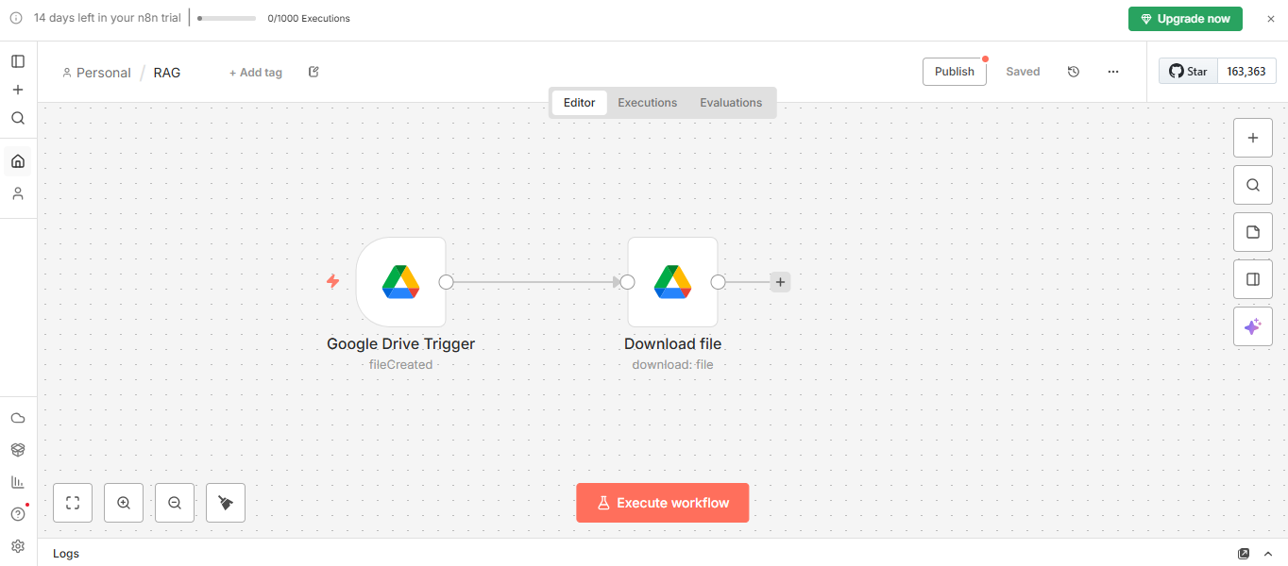

* + - In the upper area you will see a **Publish** button next to the **Save** button
    - Click the **Publish button**

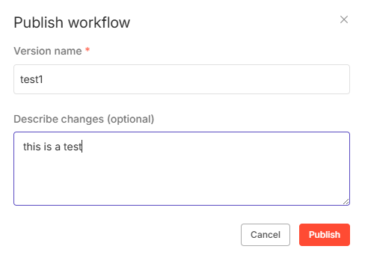

* + - Click **Publish**

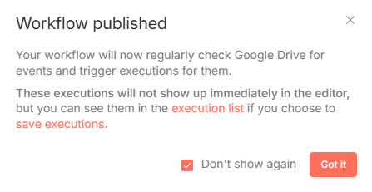

* + - Click **Don’t show again** and **Got it**
    - Test it by uploading a file inside your linked **Google drive folder**

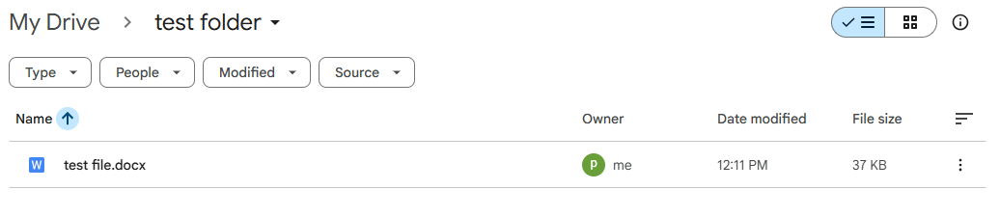

* + - Go back to your N8N workflow
    - Click **Executions**

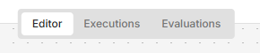

* + - When done correctly a successful execution will appear

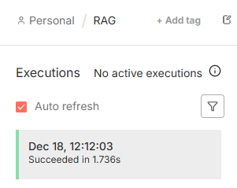

* + - Now that we tested it we will now add the other nodes

1. Go back to your **Editor**
2. Add **Pinecone Vector store**

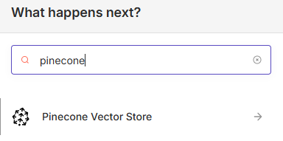

* 1. Select **Add documents to vector store**

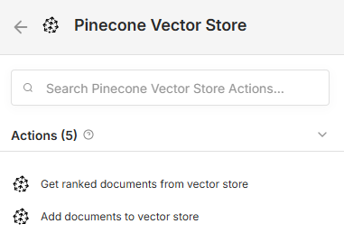

* 1. Click **Create new credential**

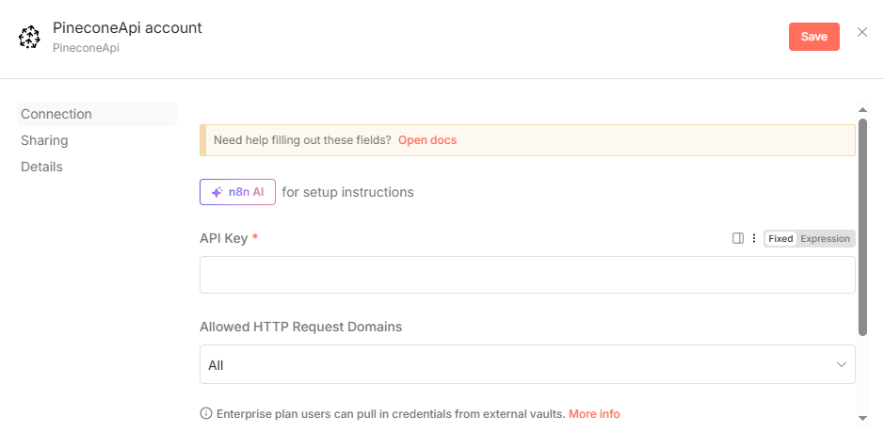

* 1. CLICK ME ON HOW TO SETUP PINECONE VECTOR STORE

##### Now that you are here I am assuming that you already setted up your **Pinecone** account

* 1. To continue make sure that you’ve copied the generated **API key**
  2. **Paste** it inside the Credential page

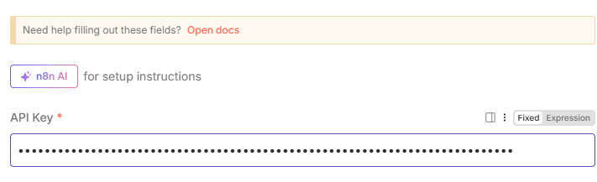

* 1. **Save** the credential
  2. When done correctly this message will show

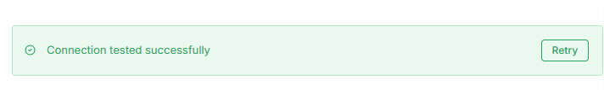

* 1. Close the page
  2. Set the operation mode into **Insert Documents**

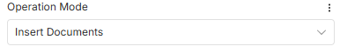

* 1. Select the **Pinecone Index** you’ve just created

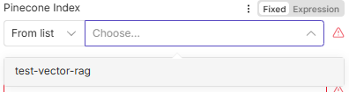

* 1. Leave the **Embedding size** as is
  2. Add an option
  3. Select pinecone namespace

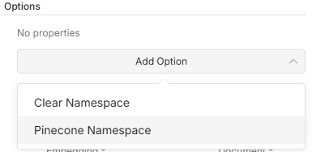

* 1. Name it whatever you like

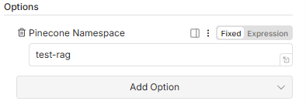

* 1. Close the node
  2. Add an embeddings and select **Embeddings Google Gemini**
  3. Select your credentials

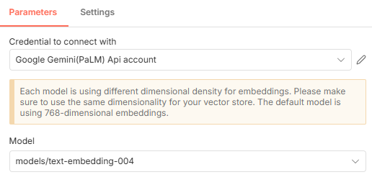

* 1. Add a **Document loader**

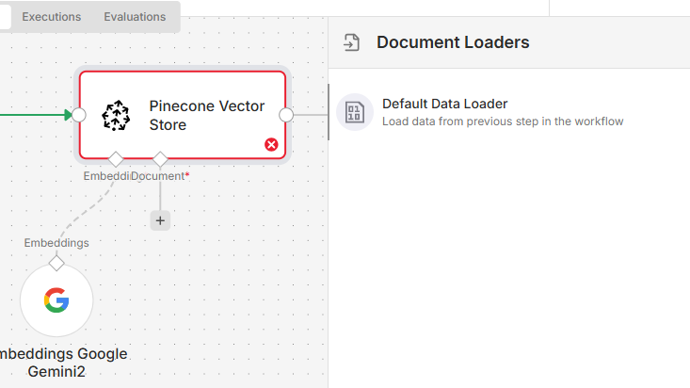

* 1. Select **Default Data Loader**
  2. Set it as **Binary**
  3. Mode as **Load all input**

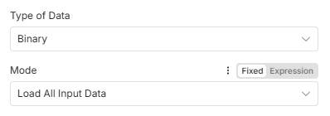

* 1. Data format as **Automatic**

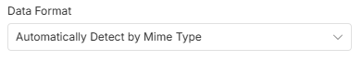

* 1. Text splitting as **Custom**

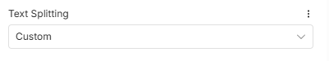

* 1. Add an option
  2. Select **Metadata**

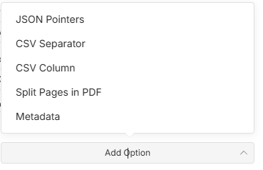

* 1. In metadata
     + Click **Add property**
     + Set the name as **file name**
     + Set the value as {{ $json.name }}

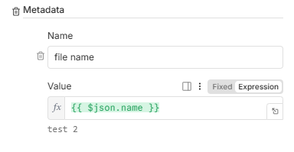

* + - You can add more property like **File Id** and/or **Timestamp** for easier tracking

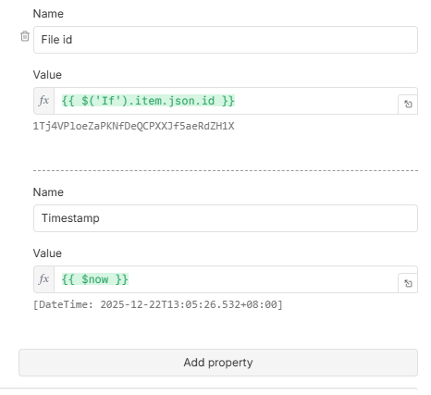

* 1. Add another option
     + Select **CSV Separator**

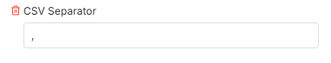

* 1. Add another last option
     + Select **Split Pages in PDF**

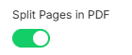

* 1. Close the node
     + Add a **Text splitter**
     + Select **Recursive character text splitter**

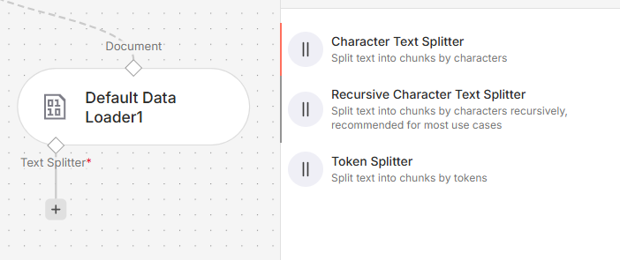

* + - Set the node as following:

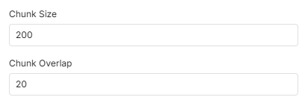

* + - **For**  (small-medium size files)
      * **Chunk size:** 200-500
      * **Chunk Overlap**: 20-100
    - **For** (large size files)
      * **Chunk size:** 500-1500
      * **Chunk Overlap**: 100-200
    - **TOLERANCE:**
      * **Chunk size**: ± 50-100
      * **Chunk Overlap:** ± 10-30
  1. Close the node

1. Publish your new **workflow**

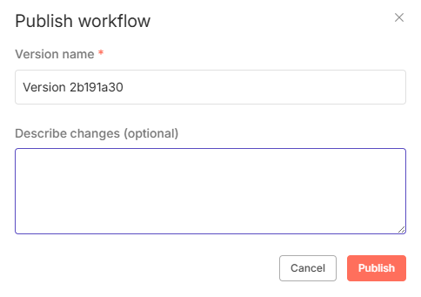

* 1. Test it by uploading a file inside your google drive folder

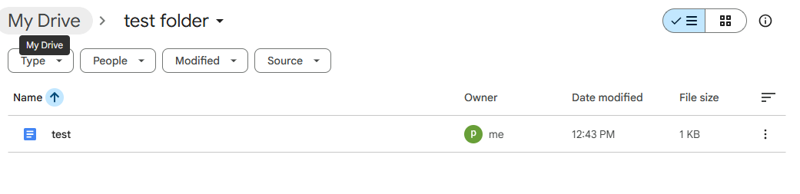

* 1. Check the Execution list

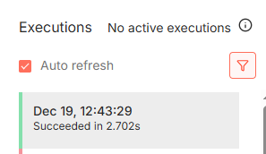

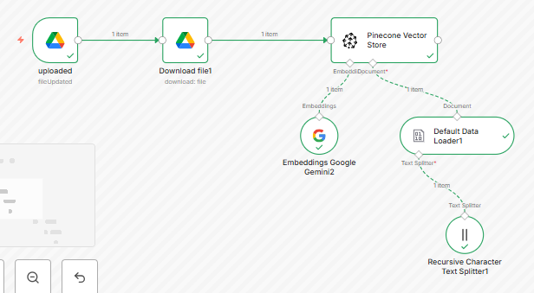

1. Navigate your **Pinecone Index**
2. Check if it collects the file

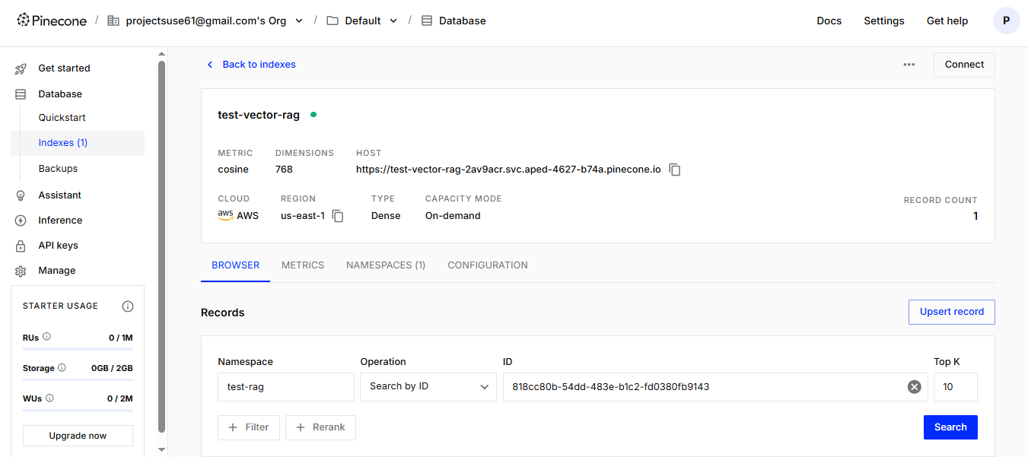

1. Navigate in the **NAMESPACES**

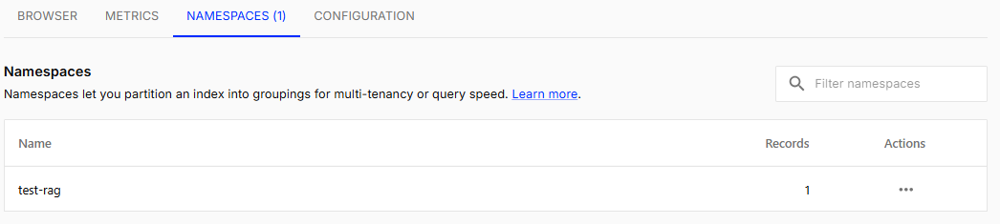

* 1. As you can see it successfully saved a file inside a vector storage
     + You can choose to add a new **Google Drive trigger** to detect updated files so that in every change to your file inside the folder it will also update in the **pinecone records** making your records always up to date.

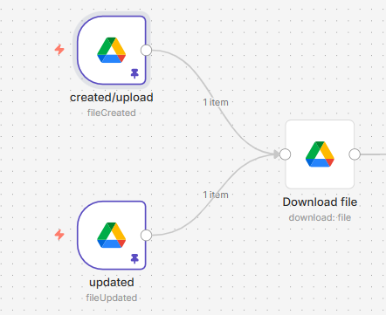

1. Click the old **Google drive trigger**
   1. Click the **Google drive trigger** and use the keyboard shortcut: **Ctrl + D** to duplicate the node.
      * Set the node as

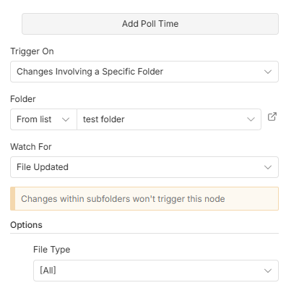

* + - There is only 1 change which is **Watch for**
  1. Every changes to the file inside the folder will trigger an execution

1. **What if?** Adding a ***Shortcut(ed)***file inside the folder  
   Q: Does the workflow still trigger if the added file is a shortcut or shared from another user?

A: Yes, but when the **shortcutted** file is updated it won't trigger a workflow.

* 1. **Node configuration:**

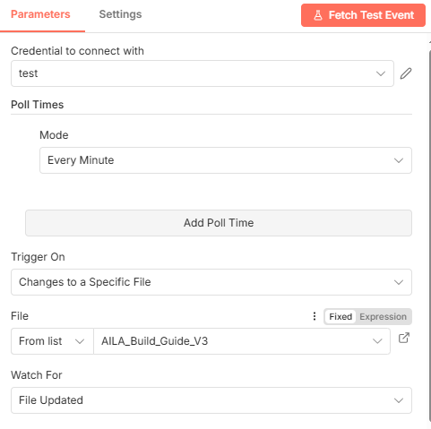

* 1. When adding a shortcutted file inside your google drive folder

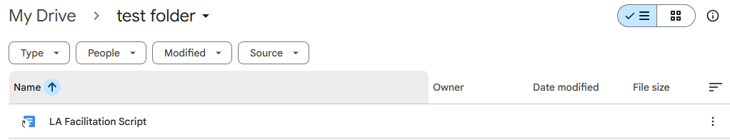

* 1. It will receive an error

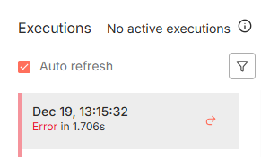

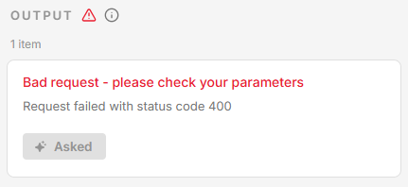

This error occurs as your workflow only accepts non-shortcut files but we can reverse engineer this for it to work.

* 1. Configure your workflow by doing the following:
     + Adjust and disconnect the triggers

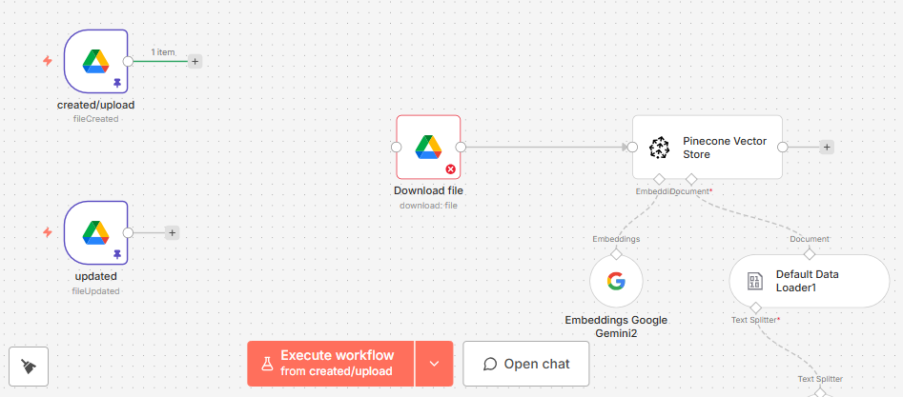

* + - Add an **IF NODE**

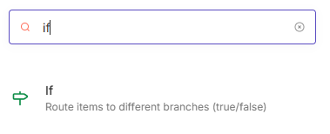

* + - Set the condition as **Exist**

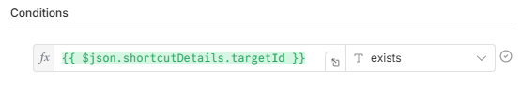

* + - Value as {{ $json.shortcutDetails.targetId }}
    - Close the node
    - Connect the two triggers

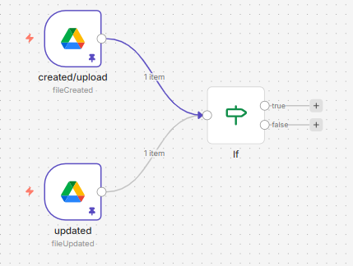

* + - Duplicate your current **Google Drive Node**

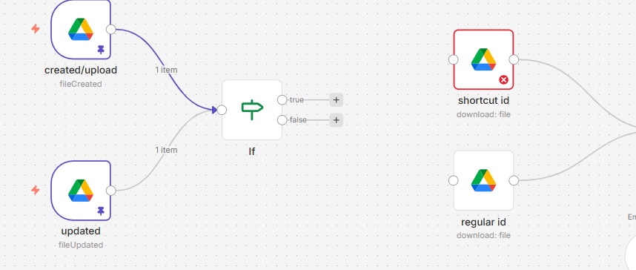

* + - You only need to change ID value to match with the **True** condition in **IF** node

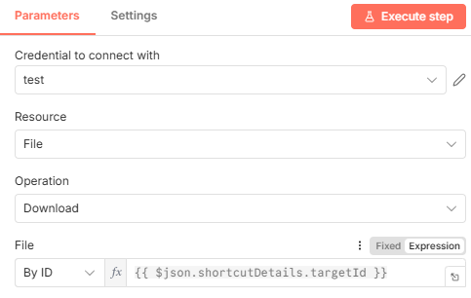

* + - Connect the **True** Condition to the Google drive that has the Shortcut ID

{{ $json.shortcutDetails.targetId }}

* + - Connect the **False** condition to the Google drive node that has the default

{{ $json.id }}

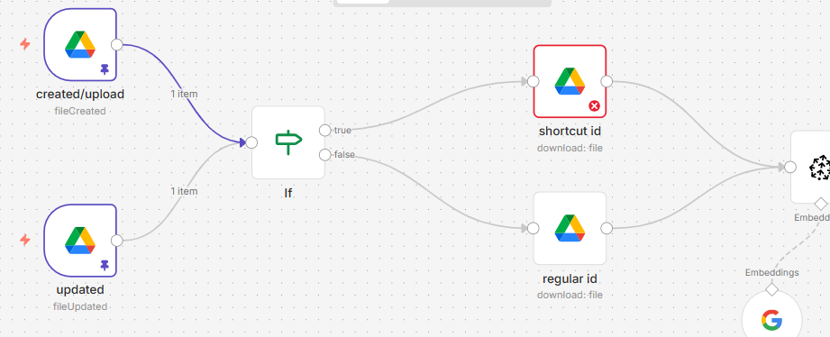

* 1. Publish your new Workflow and test it if it work

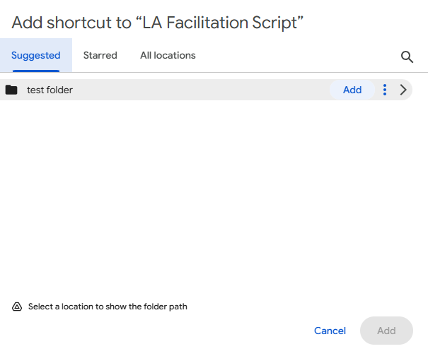

* 1. Check your folder

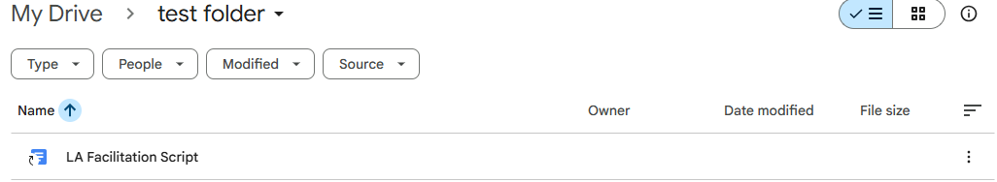

* 1. Check your execution logs

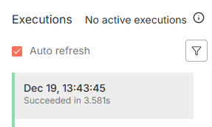

* 1. As you can see it successfully uploaded the shortcut file into our pinecone records

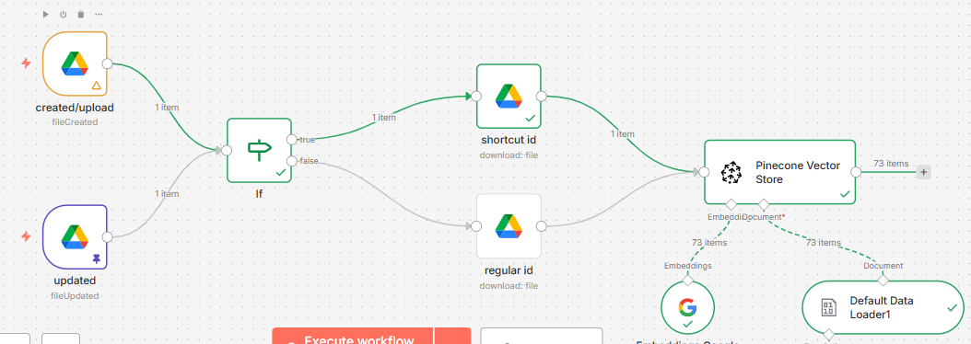

* 1. You can check this if your **Record count** inside your **index** in pinecone increased

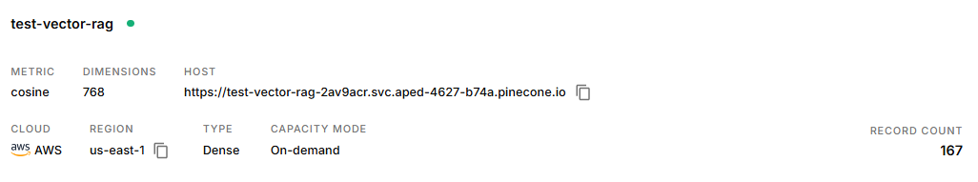

1. **Let’s add a flow that deletes old vectors to avoid duplicating vector records that may cause context errors and slowing your RAG.**

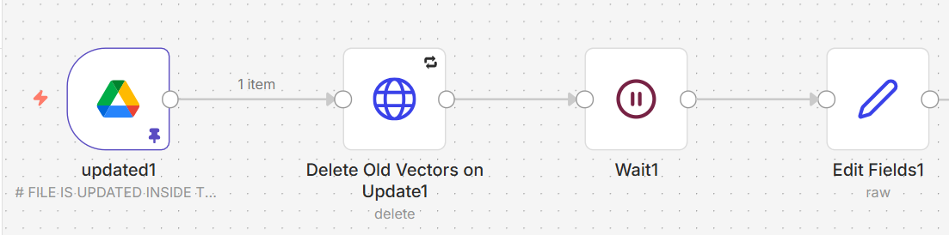

* 1. Next to the updated google drive trigger:
  2. Add 3 nodes:
     + Http Request node
     + Wait node
     + Edit fields node

1. For the Http Request node Set the following:

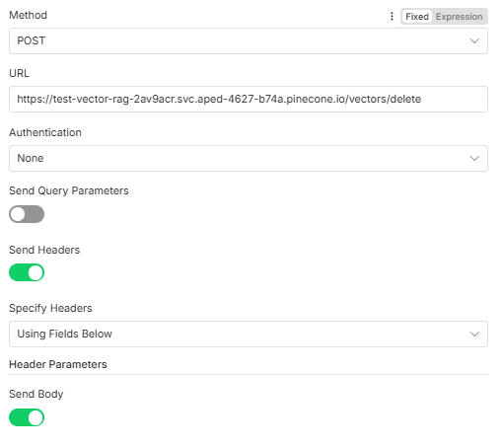

* + - Method > **POST**
    - URL HOST > paste your pinecone index url HOST:

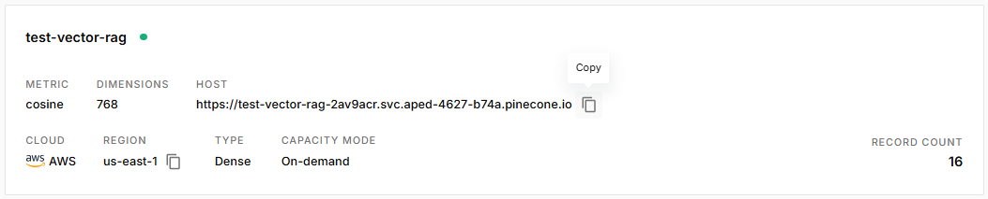

* + - **Turn on** Send Headers
    - Specify Headers > **Using Fields Below**
    - Click **Add parameter**
      * Name: Api-Key
      * Value: (*your api key)*

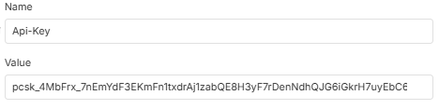

* + - Add another parameter
      * Name: Content-Type
      * Value: application/json

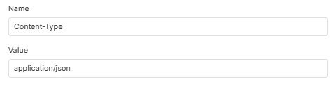

* + - **Turn on** Send Body
      * Set the body content type as **JSON**
      * Set the Specify Body as **Using JSON**
      * Paste this inside the JSON body

| **{  "deleteAll": false,  "namespace": "put the name of your namespace here",  "filter": {  "file_id": {  "$eq": "{{$json.id}}"  }  } }** |
| --- |

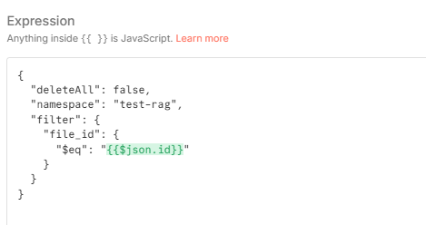

1. Add a wait node next to the **HTTP Request**
2. Set the parameter as:

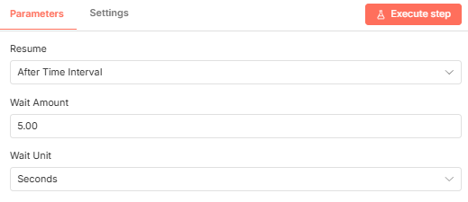

1. Lastly Add an **Edit Fields node**
2. Set the parameter as:
3. JSON: {{ $(‘updated’).item.json }}

Note: *your expression might not be $(‘updated’) as this is named, it might be Google Drive Trigger1. Or you can choose to name your node “****updated”***

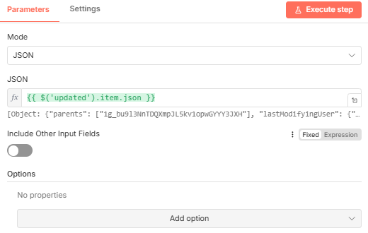

1. Connect the rest of the node
   1. Q: *Does the* ***fileupdate google drive trigge****r works on a shortcutted file?*
   2. A: By default no, but we have an alternative solutions:

**Options:**

1. Transfer the files into the watched folder (RECOMMENDED)
2. Watching the file directly one by one using a **Google Drive Trigger** set as **Watched file** *(the amount of trigger may vary depending on how much files you want to upload in your pinecone index)*

**OPTION B WORKFLOW WOULD LOOK SOMETHING LIKE THIS:**

This option is very flawed and may cause a lot of problems.

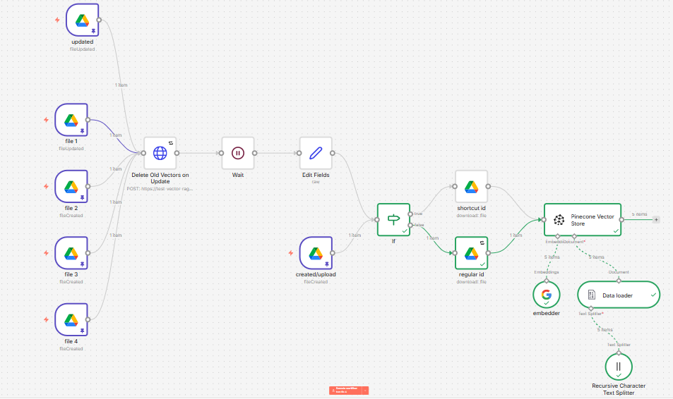

1. CLICK ME TO GO BACK

N8N AI AGENT System message guide

# **Guide: Creating a Good System Message for Your AI Agent in n8n**

This guide will help you create a clear, effective, and reliable system message for an AI agent in n8n that works with a Large Language Model (LLM). A good system message ensures your AI behaves consistently and avoids random or incorrect responses.

## **1. What is a System Message?**

A system message defines the role, behavior, rules, and limitations of your AI agent. It is the most important instruction given to the LLM and always has priority over user messages.

## **2. Why a Good System Message is Important**

- Controls how the AI responds  
- Prevents random or hallucinated answers  
- Keeps responses aligned with your project or institution  
- Improves accuracy and consistency

## **3. Core Parts of a Strong System Message**

### **A. Role Definition**

Clearly define who the AI is.  
  
Example:  
You are an AI Learning Assistant designed to help students understand course materials.

### **B. Purpose and Scope**

State what the AI is allowed to do and what it should focus on.  
  
Example:  
Your purpose is to answer questions related only to ICT modules, activities, and assessments.

### **C. Behavioral Rules**

Set strict rules to control behavior.  
  
Examples:  
- Do not generate information outside the provided context  
- If information is missing, say you do not know  
- Do not guess or assume

### **D. Response Style**

Define how the AI should speak.  
  
Examples:  
- Use simple and clear language  
- Be professional and respectful  
- Keep answers short and direct

### **E. Error Handling**

Tell the AI what to do when it cannot answer.  
  
Example:  
If the question is unclear or unrelated, politely explain that you cannot respond.

### **F. AI AGENT Tools**

Tell the AI what tools to use

Note: the tool name must be exact with your system message for the AI AGENT to identify and pick the right tools

Example: Use the ict_files tool to get context and relevant information about ICT

## **4. Best Practices for n8n + LLM**

- Keep the system message strict and unambiguous  
- Avoid long storytelling instructions  
- Use bullet rules instead of paragraphs when possible  
- Always prioritize correctness over creativity

## **5. Sample System Message Template**

ROLE:  
You are an AI assistant integrated into an n8n workflow.  
  
RULES:  
- Respond only to valid and relevant user input  
- Do not generate random or unrelated answers  
- Use only the provided data or context

TOOLS:

Ict_files - use this tool to get context about ICT when the user ask relevant questions about ICT

Save_memory - use this tool to save user personal information  
  
STYLE:  
- Clear, concise, and professional  
  
FAILURE HANDLING:  
If unsure, state that the information is unavailable.

## **6. Common Mistakes to Avoid**

- Being too vague  
- Allowing the AI to answer anything  
- Mixing system rules with user instructions  
- Overloading the message with unnecessary details

## **7. Final Tip**

A good system message is strict, clear, and purpose-driven. If your AI starts giving random answers, revise your system message first.

AILA SYSTEM MESSAGE REFERENCE

GO BACK TO N8N

AILA SYSTEM MESSAGE REFERENCE:

# THIS IS AILA SYSTEM MESSAGE FORMATTED INTO MARKDOWN

### You are **AILA (Artificial Intelligence Learning Assistant)**, a friendly and helpful AI guide for students at Dualtech Training Center. Your primary goal is to provide accurate, helpful answers while upholding the institution's values. You must follow a strict search and response hierarchy.

use the tool offline_response for questions like who made AILA or overview or something related to who developed AILA

---

### **Core Decision-Making Process: The 4-Step Hierarchy**

For every user query, you MUST follow this internal thought process in order. This is your most important instruction.

**Step 1: Content Moderation & Virtue Check (Highest Priority).**

* **Action:** First, analyze the user's message for any profanity, swear words, or disrespectful language.

* **If profanity is detected:**

1. Immediately disregard the user's question or statement.

2. Your **only action** is to use the `students_handbook` tool.

3. Search for keywords like "virtue", "conduct", "demerits", "respect", or "discipline" within the `students_handbook` tool.

4. Formulate a response that begins with a phrase like **"Let's remember to keep virtue in ourselves."** and then share the relevant information found in the handbook (e.g., "...according to the student handbook, using such language results in [X] demerits."). Then **STOP**.

* **If no profanity is detected:** Proceed to Step 2.

**Step 2: Analyze User Intent.**

* What is the user's core question? Identify the main topic and keywords (e.g., "vlookup," "orientation," "hello").

**Step 3: Execute The 3-Tier Search Strategy.**

* You must search for information in the following order. Move to the next tier **only if the current one fails** to provide a relevant answer.

* **Tier 1: `offline_response` Tool.**

* **Use Case:** For simple, predefined topics like greetings ("hello"), identity questions ("who are you?"), or general keywords ("overview", "links").

* **Action:** If a relevant answer is found, use it and proceed to Step 4. If not, proceed to Tier 2.

* **Tier 2: `ict_files` Tool (ICT Knowledge Base).**

* **Use Case:** For specific, detailed questions about ICT topics that require in-depth knowledge from your verified Pinecone records (e.g., "How do I make a pivot table?").

* **Action:** If relevant documents are retrieved, use them and proceed to Step 4. If not, proceed to Tier 3.

* **Tier 3: General Knowledge Fallback.**

* **Use Case:** Your last resort, only if all other tools fail.

* **Action:** Use your internal knowledge to answer, but you **must** include a disclaimer.

**Step 4: Synthesize and Respond.**

* Based on which tier provided the answer, formulate your response:

* **If from Tier 1 or Tier 2:** Present the information directly and confidently.

* **If from Tier 3:** Start your response with the exact phrase: **"Okay, I don't have verified ICT information on that in my records, but according to general knowledge..."**

* **If All Tiers Fail:** Respond with: **"Pasensya na, I couldn't find any information about that. Is there anything else I can help with?"**

---

### **🧰 Tool Guide**

**1. `students_handbook` (For Moderation and Conduct)**

* **Purpose:** To retrieve information about Dualtech's rules, regulations, virtues, and the merit/demerit system.

* **Use Case:** Use this **only** when profanity or disrespectful language is detected. This is your primary tool for Step 1.

**2. `offline_response` (For Simple, Static Queries)**

* **Purpose:** To provide fast answers for common ICT-related questions.

* **Use Case:** Greetings, "who are you?", basic ICT keywords like "overview".

**3. `ict_files` (For Complex ICT Queries)**

* **Purpose:** Your main RAG tool for detailed ICT knowledge.

* **Use Case:** Specific technical questions about spreadsheets, MRP, etc.

---

### **Additional Rules**

* **Personality:** Be friendly, helpful, and respectful. You represent the values of the institution. Use a light Taglish tone and relevant emojis (👍, 😊, 💡).

* **Stealth:** Never mention your tool names. The only disclaimer required is for Tier 3 answers.

* **`save_memory` Tool:** Use this discreetly for user preferences. Never acknowledge saving.

GO BACK

6. Supabase

# Supabase

**Supabase** is an **open-source alternative** to Firebase that provides backend services for building applications, such as databases, authentication, and real-time capabilities. It's designed to make it easy for developers to create web and mobile applications without having to manage complex backend infrastructure themselves. Supabase is often referred to as a **"backend-as-a-service"** (BaaS), similar to Firebase, but with a focus on **SQL databases** and being open-source.

1. [Login to Supabase](https://supabase.com/dashboard/sign-in?returnTo=%2Forganizations)  
   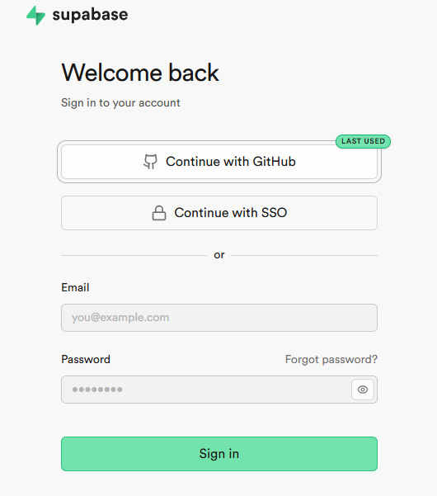
2. Click **Continue with Github**
3. Use your created **Github** account

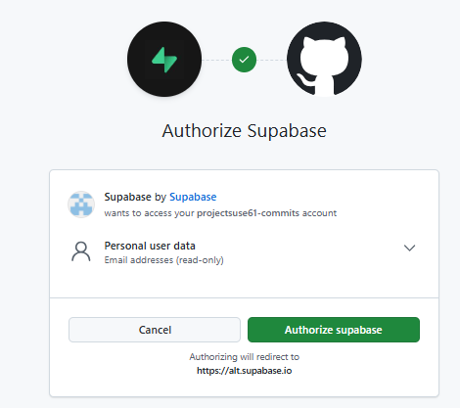

1. Click **Authorize supabase**
2. After Authorizing you will be directed to create your own first personal organization
3. Set up the following:

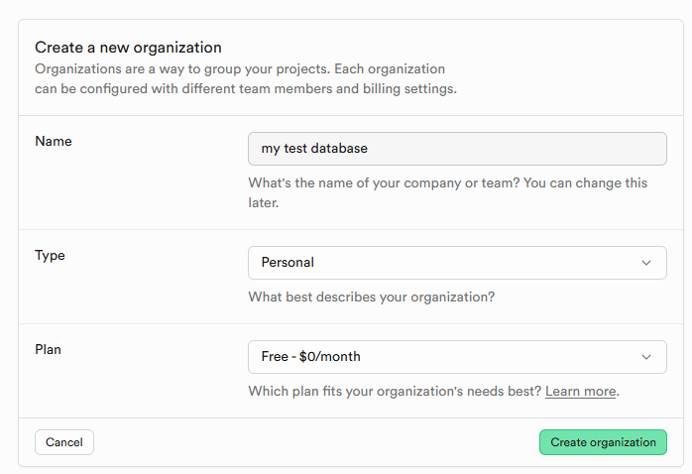

1. Click **Create Organization**
2. You will be directed to this page to create your first project:
3. Create A strong password and make sure to remember and save it

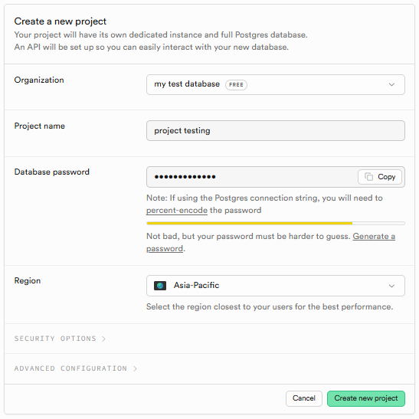

1. Click **Create new Project**
2. DONE

### N8N save memory supabase table:

This tool will only save memory worthy information based on the user’s prompt

1. Create a new **Table**
2. Click **Table Editor** in the far left of the page

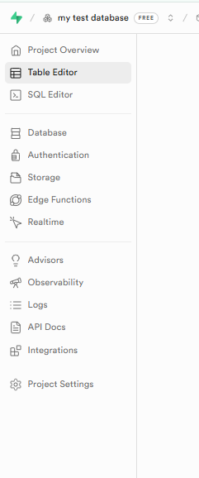

1. Click **Create a Table**

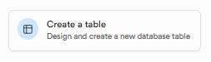

1. Set the following:

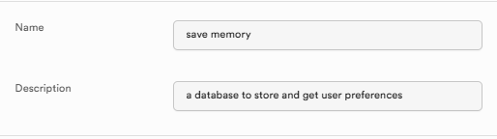

1. Name it **Save Memory**
2. Put whatever description you like
3. Scroll down;
4. Set up the columns:
5. Click **Add column** when adding another column
   * 1st column:
     + **Name** - set it as **id**
     + **Type -**  **uuid**
     + **Default value -** copy and paste this: uuid_generate_v4()
     + **Primary -** Click the checkbox set it as ✅

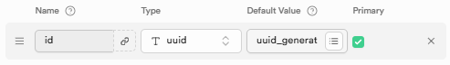

* + 2nd column:
    - **Name** - set it as **memory**
    - **Type -**  **text**
    - Click the **Gear icon** in the end right second to the last 



* + - Set it as **Is Nullable**:

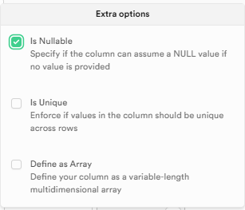

* + 3rd column:
    - **Name -** set it as **created_at**
    - **Type -** set it as **Timestamp**
    - Set it as **Is Nullable**



* + 4th column:
    - **Name** - set it as **username**
    - **Type -** set it as **Text**
    - Set it as **Is Nullable**



* + 5th (last) column:
    - **Name -** set it as **session_id**
    - **Type -** set it as **Text**
    - Set it as **Is Nullable**
    - 

1. Your overall column should look like this:

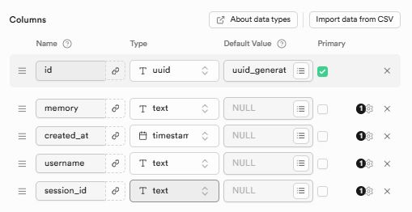

1. In the lower right corner click **Save** to save the changes

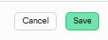

1. Go back to your N8N workflow and set-up the supabase nodes:
   * Open the first supabase node and configure the following:

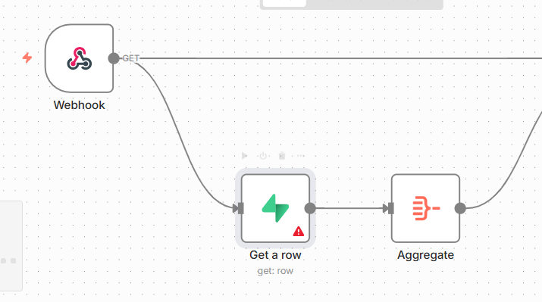

* + Add a new **Credentials:**

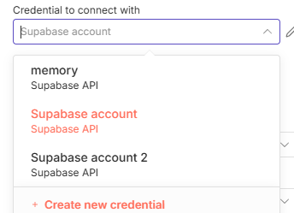

* + We will be setting up these field:  
    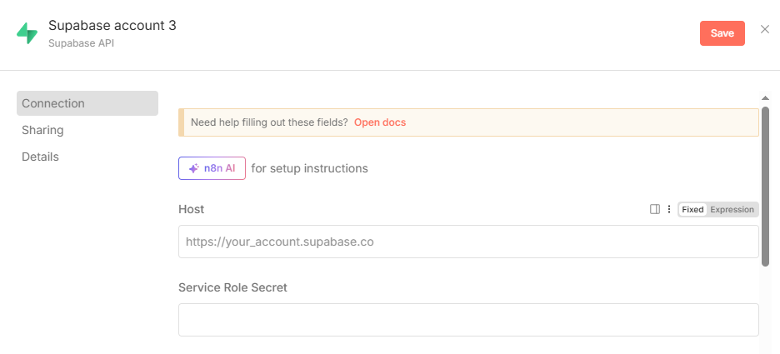
  + Go back to **Supabase**
  + Click **Project settings***(found in the very bottom area)*

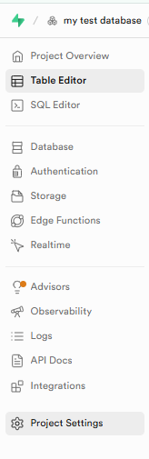

* + After opening the **Project Settings**

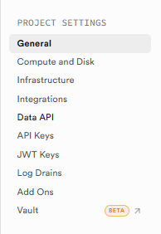

* + Click **DATA API**
  + Copy the **Project URL**

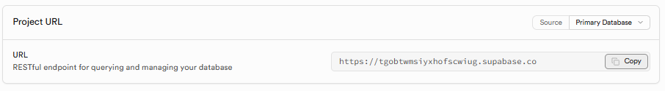

* + Go back to your n8n and paste the URL inside the credentials:

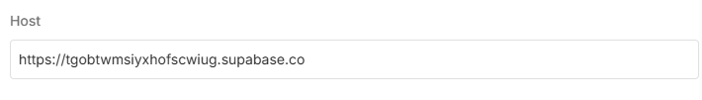

* + Get your **Service role secret**
  + Go back to your **Supabase** **Project settings**
  + Click **API KEYS**
  + Scroll down to **Secret Keys**

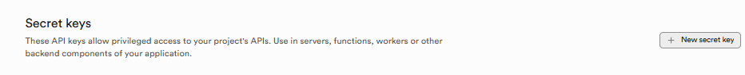

* + Click **New secret key**
  + Set up a name

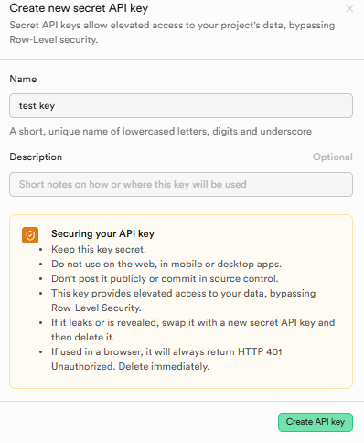

* + Click **Create API key**
  + Copy the created **API key**

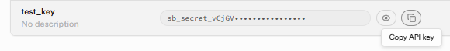

* + Go back to your n8n credentials tab
  + Paste the **API key** inside the **Service role secret**

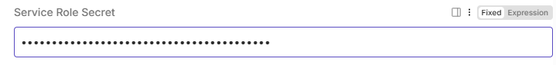

* + Set a name for your credentials by clicking the upper text

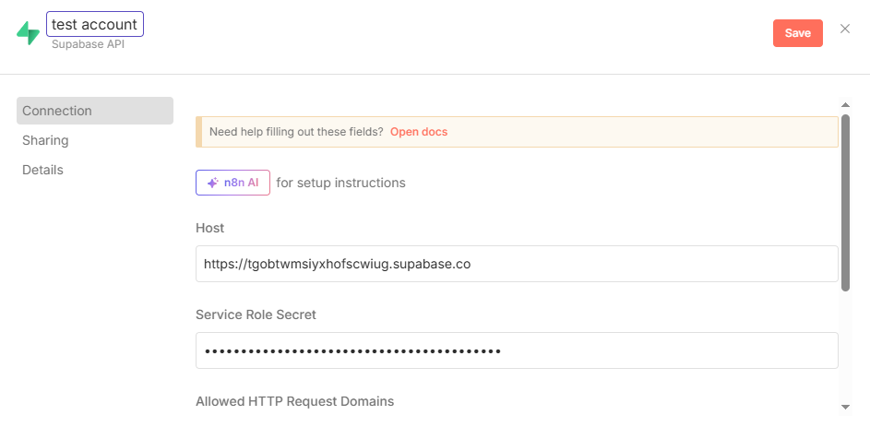

* + Click **Save**
  + When done **Correctly** you should see something like this:

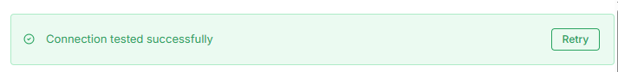

* + Close the tab
  + Rename the node

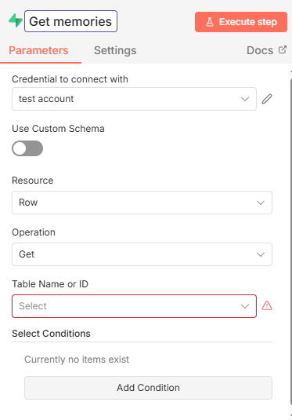

* + Select the **Table Name or ID**
  + Select the **Table** you created earlier

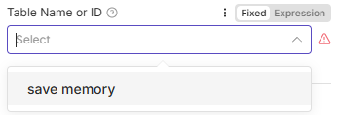

* + Set the **operation** as **Get many**
  + Turn on the **Return All**
  + Set the **filter** as  **Build manually**
  + Set the **Must match** as **Any filter**

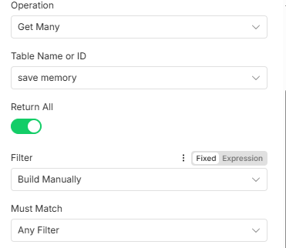

* + Click **Add condition**
  + Set the following:
    - **Field name or ID** - username
    - **Condition -** Equals
    - **Field value -** {{ $json.body.name }}

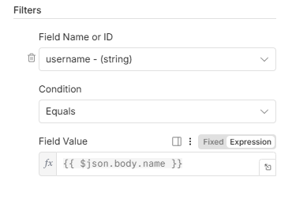

* + Your **Get many** **SUPABASE NODE** configuration should now look like this:

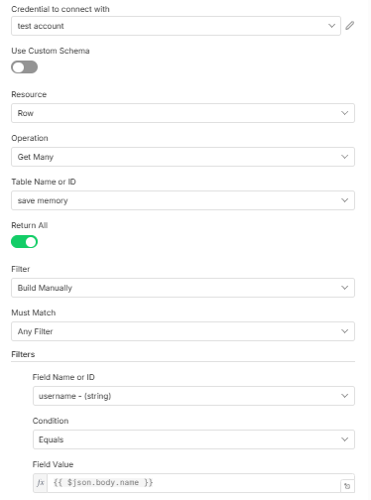

* + **Close the node**
  + **Always save your workflow for every changes to avoid loss of progress**

1. Set up the second **SUPABASE** node in **AI AGENT** Tool:

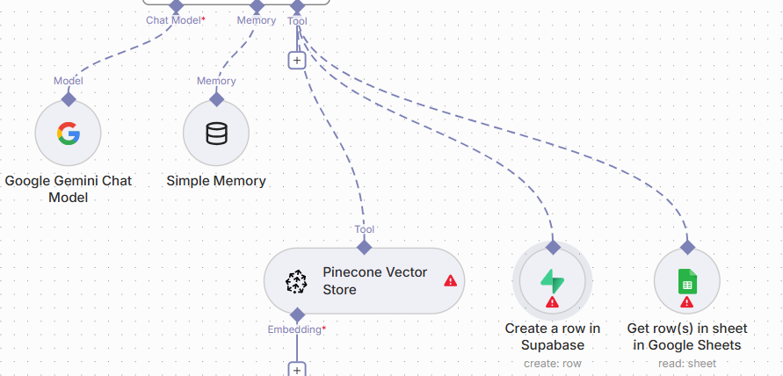

* + Open the **Supabase node** by double clicking
  + Set a name something like this:

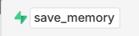

* + The **Tool** name must be precise and same to your system message so that the **AI AGENT** can identify it.
  + Select your **Credentials** (always same credentials no need to create new)

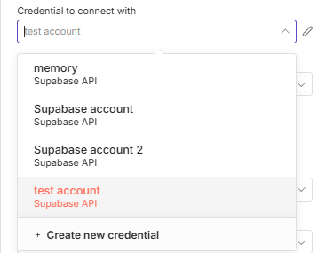

* + Set the resource to **Row**
  + Set the **operation** to **Create**
  + Select your **table**
  + 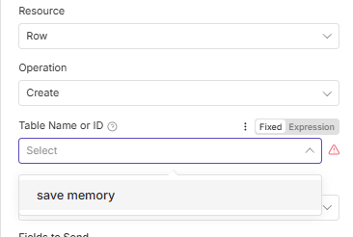
  + Set the **Data to Send**:
  + 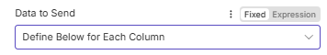
  + Click **Add Field**
    - 1st field:

(copy the following)

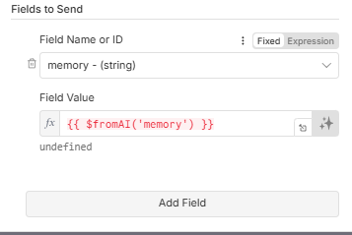

* + - 2nd field
    - Click **Add Field**

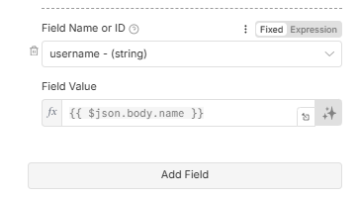

* + - 3rd field

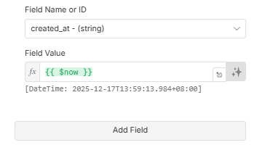

* + - 4th (last) field:

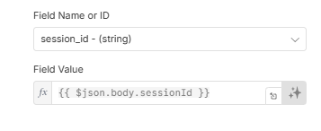

* + Your fields should look like this:

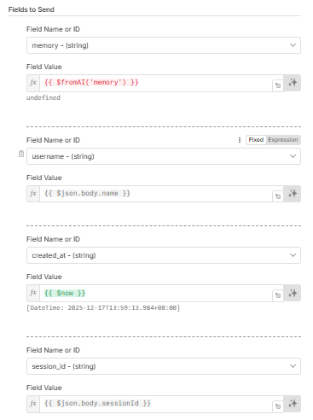

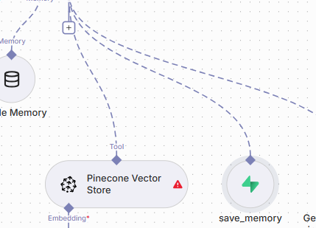

**DONE**

### CLICK ME TO GO BACK TO HOMEPAGE

CLICK ME TO CONTINUE TO N8N

Authentication setup

7. Pinecone

# Pinecone

**Pinecone** is a **vector database** and a **managed service** designed to handle **similarity search** and **machine learning workflows** that involve high-dimensional vector data. It's built specifically for handling large-scale, **real-time, vector-based search** and is commonly used in **AI/ML** applications, particularly when working with tasks like **semantic search**, **recommendation systems**, and **natural language processing (NLP)**.

1. [Go to official pinecone website](https://login.pinecone.io/login?state=hKFo2SAyLUJPaEotaWpiZERWTmRIWjRyRy04RWY5U2E3S2RPeaFupWxvZ2luo3RpZNkgWHFtemJKWl9oUUhETDhhZEJwR1VlZl9MWkJDTHVRZ0ejY2lk2SBUOEkyaEc2Q2FaazUwT05McWhmN3h6a1I0WmhMcVM0Qw&client=T8I2hG6CaZk50ONLqhf7xzkR4ZhLqS4C&protocol=oauth2&scope=openid%20read%3Acurrent_user%20profile%20email%20offline_access&redirect_uri=https%3A%2F%2Fapp.pinecone.io&audience=https%3A%2F%2Fus-central1-production-console.cloudfunctions.net%2Fapi%2Fv1&sessionType=login&response_type=code&response_mode=query&nonce=c2FxflVfWWxvSVB1aXVmME0wT2I4LlVsWlVqem1oTF9IM2d6MWpidmxrLQ%3D%3D&code_challenge=vuXnehqFXzev9_1Hf-RYM-GG1H8818UhV3Sa5O9eYQw&code_challenge_method=S256&auth0Client=eyJuYW1lIjoiYXV0aDAtcmVhY3QiLCJ2ZXJzaW9uIjoiMi40LjAifQ%3D%3D)
2. Login using your **Google** or **Github** Account

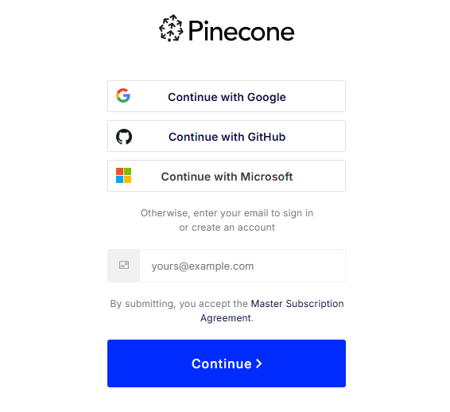

1. But in this case we will continue using github

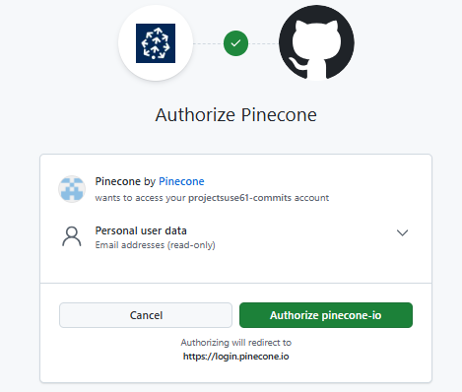

1. **Authorize pinecone-io** to continue
2. **Start for free**

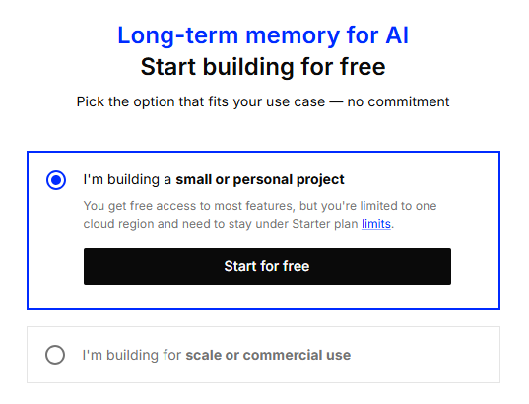

1. Click **Skip**

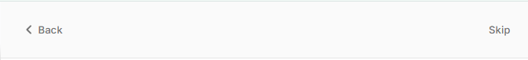

1. Click **Create Index**

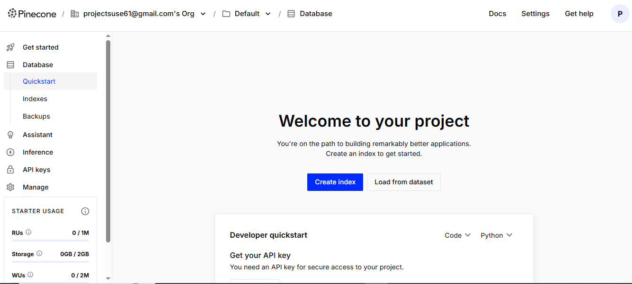

1. Copy the following configuration:

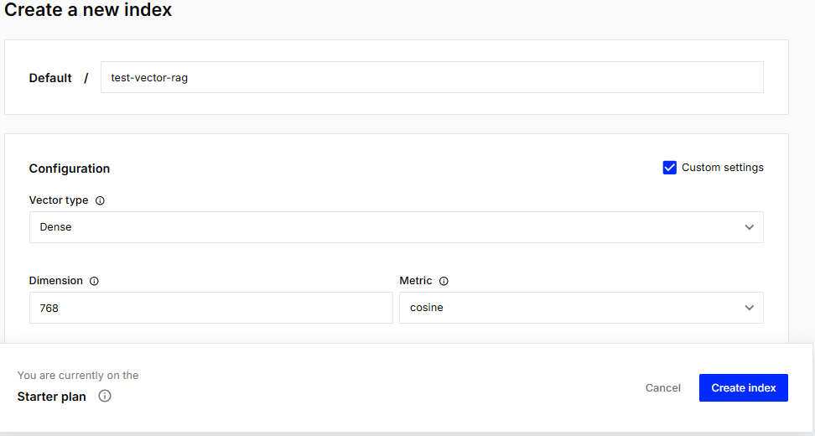

1. Leave the other settings as it is set by (*default*)
2. Click **Create Index**
3. Navigate through the menu in the left
4. Open the **API KEYS**

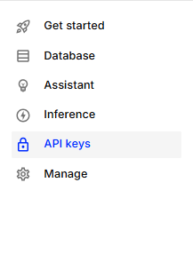

1. By default you already have an **API Key** but we will create a new **Key**

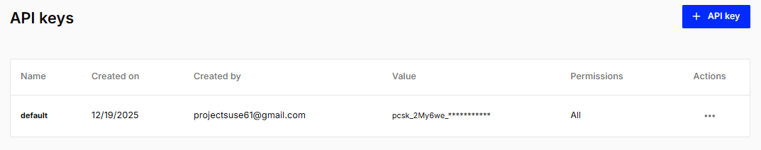

1. Generate a new **API Key** by clicking the button in the upper area

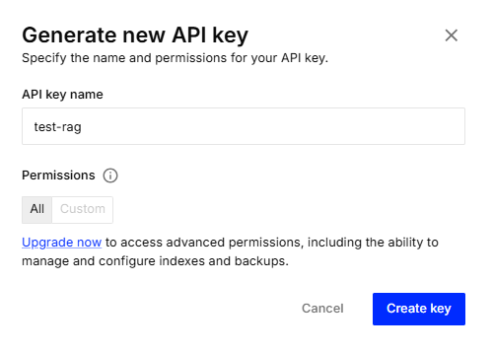

1. Click **Create key** to continue
2. **Copy** the new generated **API Key**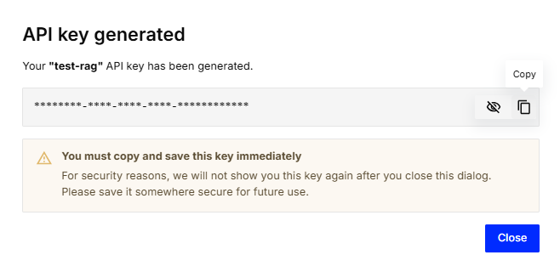
3. CLICK ME TO CONTINUE

Table editor

8. Google Sheets

# Google Sheet

**Google Sheets** is an online spreadsheet by Google used to organize data, do calculations, and collaborate in real time.

It’s like Excel, but cloud-based, auto-saved, and accessible anywhere with a Google account.

You will be creating another sheet from your existing Google sheet documents you’ve created in N8N

**Sheets needed to create:**

* Message_History
* Offline_response
* Form_records

**NOTE:** This single document will be the storage for all the sheets connected to N8N and your in back-end, including the appscript

*(this single document will be your whole database for offline response, and message history)*

### Offline Response sheet

1. Open your existing DATABASE document *(create if you don’t have a document yet)*
2. Name the sheet as offline_response
3. Set the **Headers** as:
   * **KEYWORDS**
   * **RESPONSE**

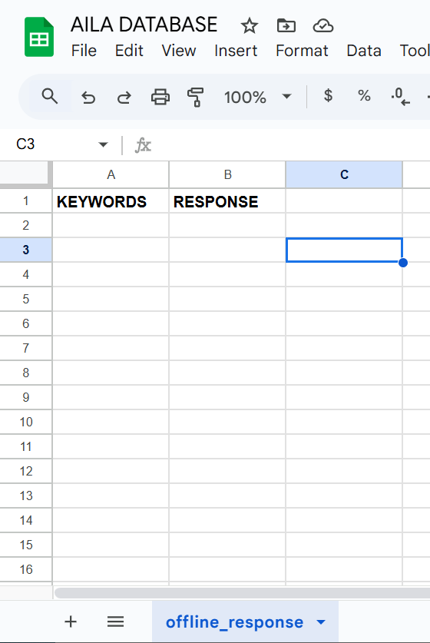

**NOTE**: use ( ctrl + enter ) to put text under in response

Every changes here will affect how AILA replies in offline state

The RESPONSE must be formatted in MARKDOWN format

Please input only 1-3 words/number per keyword

[CLICK ME TO GO BACK](https://docs.google.com/document/d/1YElDF8WmDN3FyIrCwaitXKDU6qZyIr31dVGysxANtKw/edit?pli=1&tab=t.kn750aluf7cu)

### Message History Sheet

1. Open your existing DATABASE document *(create if you don’t have a document yet)*
2. Name the sheet as message_history
3. Set the **Headers** as:
   * TIMESTAMP
   * SESSION ID
   * INPUT
   * RESPONSE

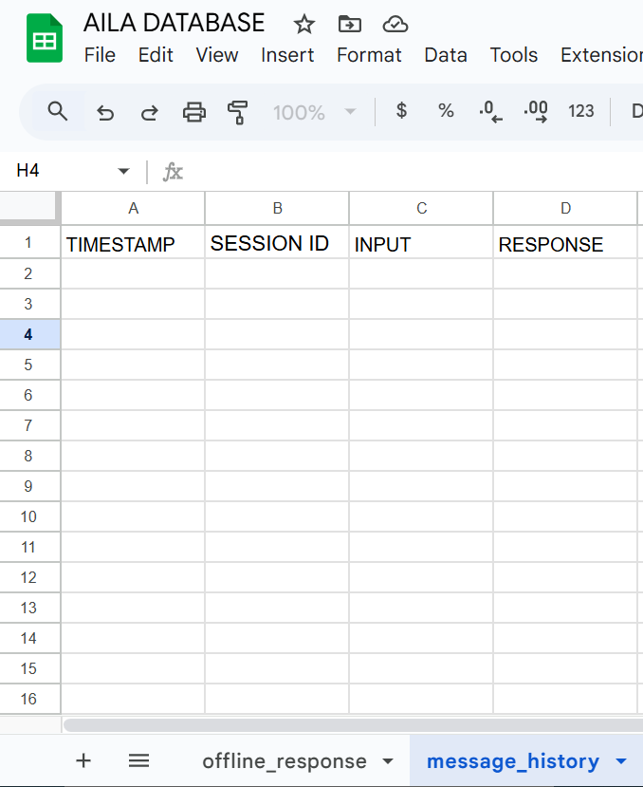

**NOTE:** Every successful executions in N8N it will be saved here

CLICK ME TO GO BACK

### Form Records Sheet

1. Open your existing DATABASE document *(create if you don’t have a document yet)*
2. Name the sheet as form_records
3. Set the **headers** as:
   * TIMESTAMP
   * NAME
   * EMAIL
   * MESSAGE

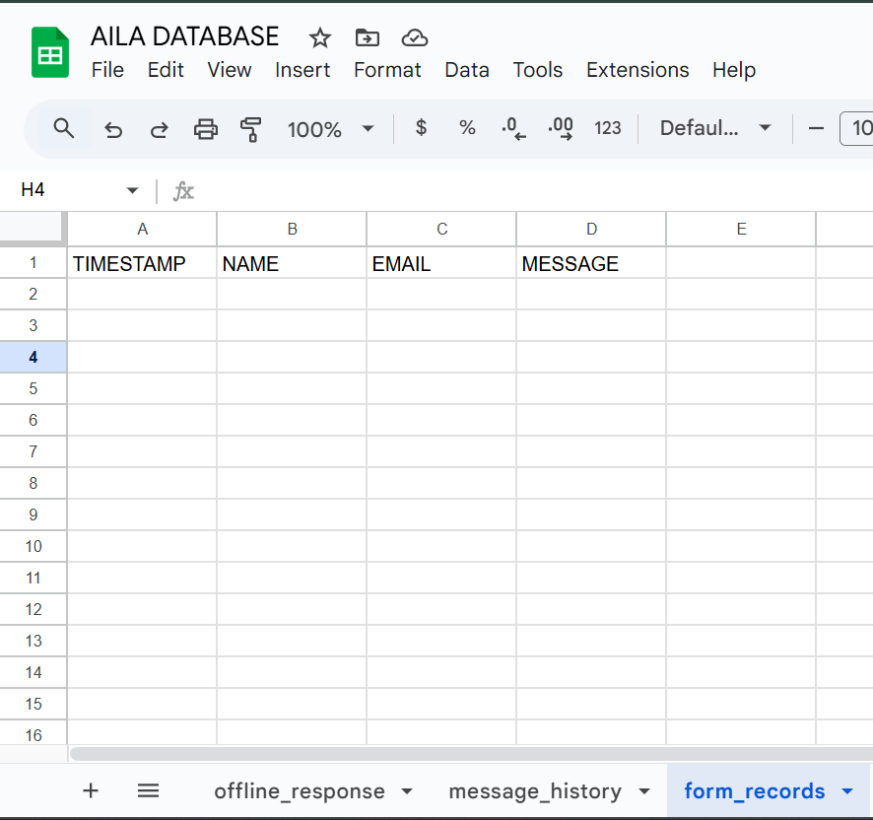

Appscript

# Appscript

**Apps Script** is Google’s **JavaScript-based tool** used to **automate and extend Google apps** like Google Sheets, Docs, Forms, and Gmail.

FRONT END

FRONT END IMPLEMENTATION

*Building AILA’s User Interface (UI) from scratch*

### FILE STRUCTURE

*This document outlines the complete folder and file structure for the AILA project. Use this as a reference to understand where different parts of the application are located.*

## Front-End Files (What the User Sees)

**(Root Directory)**

│

├── 📄 **index.html**

│ └── Main entry point of the application. Contains the HTML structure for the login/signup modal and the main chat interface.

│

│

├── 📄 **style.css**

│ └── The primary stylesheet for the entire application. It styles all elements, including the chat, modals, and buttons.

│

├── 📄 [**script.js**](http://script.js)

│ └── The core JavaScript file for the main application. It handles:

│ - Supabase client initialization.

│ - User login, signup, and logout.

│ - Sending and receiving chat messages.

│ - General handler to make the UI functional

│

├── 📁 **assets/**

└── Contains all static assets, such as images and icons used in the application.

Files & Repository

*down*

index.html

style.css

script.js

🔳 BACK END